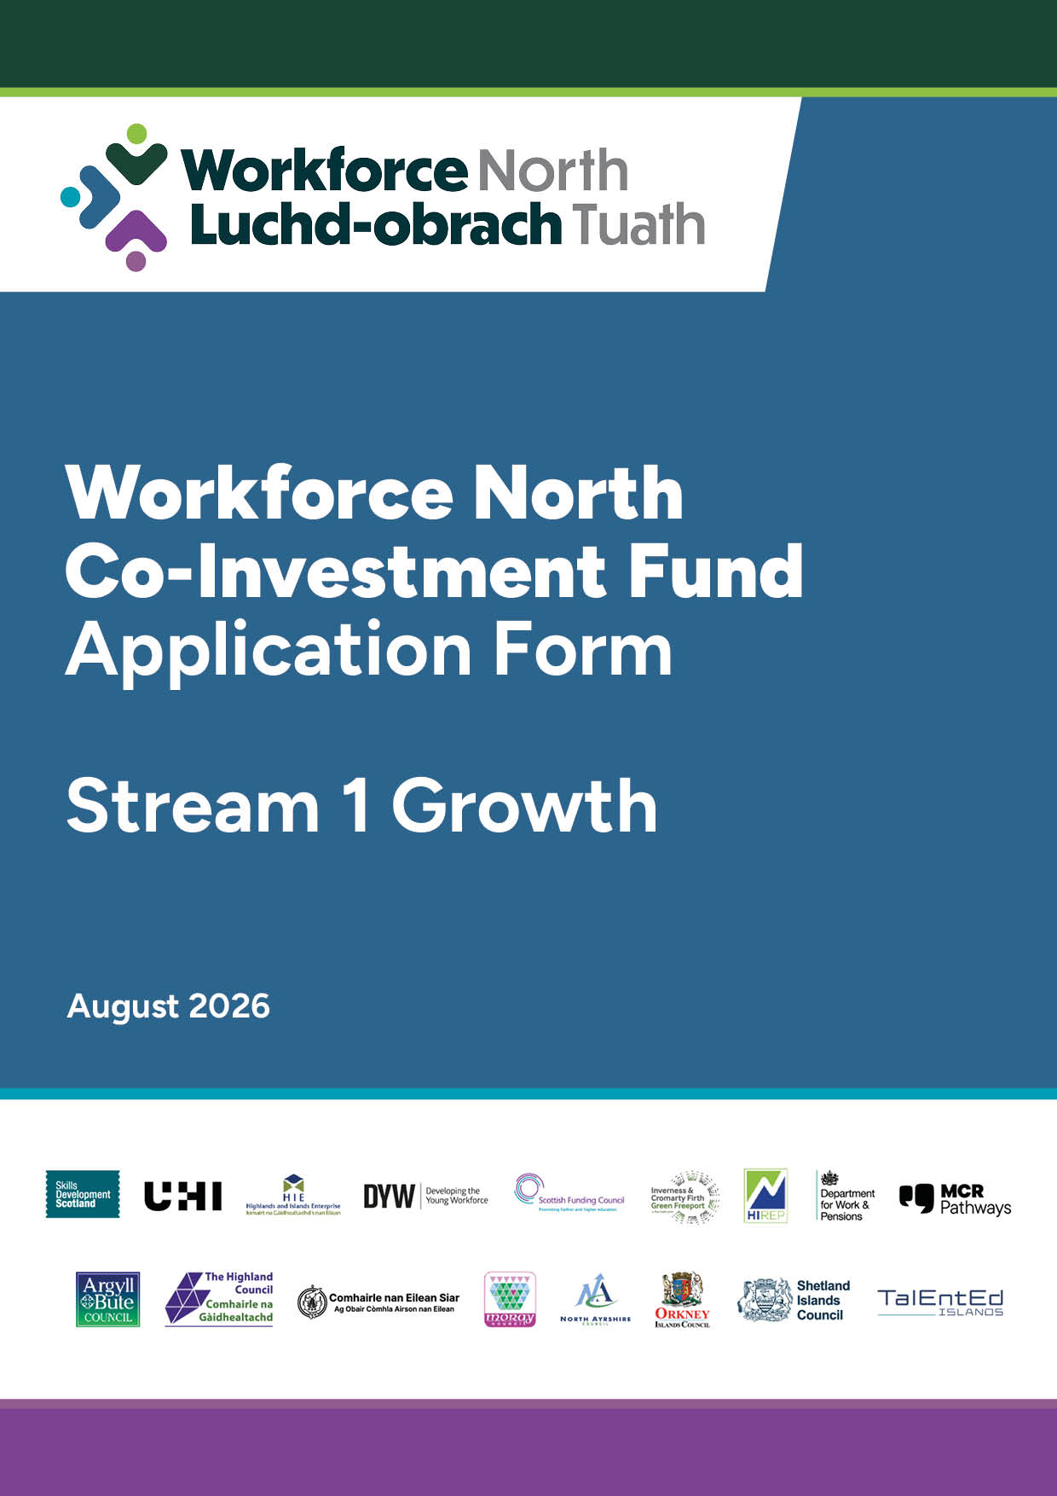


Co-Investment Fund
APPLICATION FORM A: Stream 1 Growth

Important Instructions
General
- Please refer to the Stream 1 Guidance and the General Guidance including the scoring.
- Please save this application form on your computer before starting to complete.
- Please ensure that all questions are answered and that any documents requested are provided.
- If you have any questions in completing this application, please email WFN@highland.gov.uk
- Please submit applications to WFN@highland.gov.uk

Section 1: Lead Applicant Details
  - Business Details
Business Name:
Business address (registered office):

Please confirm which of the WFN Local Authority area’s you function within | Argyll & Bute  Comhairle nan Eileen Siar  Moray Council  Orkney Islands Council  Shetland Islands Council  The Highland Council  The Islands of Arran and Cumbraes (North Ayrshire) | ☐  ☐  ☐  ☐  ☐  ☐  ☐
Address (Local Office in WFN geography):

Website:
Company Registration Number:
UTR (HMRC Ref)

  - Business Structure
Sole trader | ☐
Partnership | ☐
Limited company (if yes, please provide registration number) | ☐
Social enterprise | ☐
Other | ☐
Is your company VAT registered? | Choose an item.
How many Full time Equivalent (FTE 35 hours per week and above) Employees do you have?
Are you a supply chain partner (≤249 FTE) of a larger employer (≥ 249 FTE), where that larger employer is operating in the WFN Geographical Region and holds a direct contract for major construction or infrastructure projects | Choose an item.

  - Applicant Contact Details (They must have a good knowledge of this application)
Forename(s) |  | Surname
Position in Business:
Address (if different than the above):

Phone number/s:
Email address:

Does the main contact have any communication needs? E.g. textphone, sign language, large print? Choose an item.
If yes, what are they?

1.4 Bank Account details – must be used for business purposes only
Bank:
Account Name:
Sort Code:
Account Number:

Section 2: Your Application
2.1 Which Priority Sector/ Subject area does your application sit within?
Net Zero  Construction and Built Environment  Digital and Data Skills  STEM related subjects and progression opportunities | ☐  ☐  ☐  ☐

2.2 Have you communicated with your Local Authority regarding your application?
Choose an item.
If yes, please provide the name of who you communicated with.

2.3 Which Element of Workforce North Grow are you applying too?
A - Training and Skills, please go to 2.4 | ☐
B - Employer Recruitment Incentive for New Apprenticeships, please go to 2.5 | ☐

2.4 Training and Skills ONLY
Are the trainee(s):
Existing employees | ☐
Unemployed | ☐

2.4.1 If the trainee/s are unemployed, please detail job opportunity within WFN geography. Please note that job must be available within 4 months of training. Applicants must also refer to the trainee eligibility with the Guidance.
Text box will expand as required

2.4.2 Proposed Training: Please provide information on the planned training/qualifications. Include where relevant:
- Confirmation that this is new learning rather than recertification
- Is industry recognised or SCQF – rated (or equivalent)
- Improves employment prospects
- Will be completed within programme timescales
- That if for unemployed, that the training is linked to actual job opportunities within organisation
Text box will expand as required

2.4.3 Please provide details below of training provider:
Training Provider Name:
Address:
Is the training provider accredited from a recognised awarding body/industry to provide training services OR be established suppliers of same/similar services. Please describe below:
Text box will expand as required

2.4.4 Training and Skills Costs
Please complete the spreadsheet at 2.7 It is mandatory to complete to allow the application to proceed.
2.5 Employer Recruitment Incentive for New Apprenticeships ONLY
Are you a Living Wage Employer – i.e. you pay all employee, including apprentices at least the real living wage (currently £13.45 per hour) and are able to evidence, if requested? | Choose an item.
Is your application to support an apprentice who has been made redundant by another employer? | Choose an item.
Are you providing channels for effective worker’s voice? Please describe:
Text box will expand as required

How many Modern Apprenticeships are within your organisation
12 months ago:
6 months ago:
Currently:

2.5.1 Please complete spreadsheet at 2.7 – it is mandatory to complete to allow the application to proceed.

2.6 Please complete for both Training & Skills and Employer Recruitment Incentive – New Apprentices
How will the Workforce North Growth grant address identified skills gap / identified workforce needs quickly and effectively?
Text box will expand as required

2.7 Please complete the undernoted excel sheet for Training and Skills and Employer Recruitment Incentive – New Apprentices.
It is mandatory to complete this excel sheet to allow the application to proceed. Once completed, please ensure you click the Save button in Excel before submitting your application.

Section 3: Subsidy Control
Has your business received financial support which you have been notified as a subsidy that has been received or is currently awarded to you within the last three years? |  |  |  | Choose an item.
If yes, please complete the table below:
Date the support was received | What was the support for? | Who was it from? | How much was the support for?
 |  |  | £
 |  |  | £
 |  |  | £
 |  |  | £

Section 4: Finance
4.1Training & Skills Fund ONLY: From the completed excel spreadsheet, please provide a summary of the grant requested for
Total Cost | Grant Requested  (25% from WRF Seed Fund) |  | Total Contribution  from Local Authority, and only if confirmed. |  | Total from  Private Sector
£ | £ |  | £ |  | £
Employer Recruitment Incentive Apprenticeship Fund ONLY From the completed excel spreadsheet, please provide a summary of the grant requested for
Number of New/additional apprentices |  | WFN Seed Fund Grant Requested  (£2500 per apprentice) |  | Total Contribution  from Local Authority (£2,500 per apprentice and only if confirmed.
 |  | £ |  | £

4.2 Additionality: Why is Workforce Funding required?
- What would happen without grant support?
- Have other funding sources been explored and considered?
- Confirmation that there is not double -funding – i.e. not being funded by other sources
Text box will expand as required

Section 5: Declaration & Checklist
5 Attachments
As well as this form, please confirm you have submitted the following:
Your most recent annual accounts (a link can be provided) | Choose an item.
A bank statement of less than three months old showing bank account name, account number and sort code and matching the details provided within the application form. All balances can be detracted | Choose an item.

5.1 Declaration

We confirm that we are allowed to submit this application on behalf of:

Name of Lead Applicant Organisation

We undertake to ensure that all the necessary enclosures are included, that the information is, to the best of our knowledge, accurate and that this application complies with the eligibility guidance.

The data you have provided in the application and claim forms will be recorded on an electronic database and are subject to the provisions of the Freedom of Information Act (Scotland) Act 2002, the Data Protection Act 1998.

Under the Data Protection Act 1998 and in accordance with the GDPR 2016, we need your consent to share personal information about your organisation with organisations. Please confirm, by ticking the box below you have read and accept the Privacy Notice Terms, available to view on the Workforce North Co-investment Fund webpage.

I confirm ☐

Signatory 1
Print Name: | Signature: | Date:
Role in Organisation

