Integrated Equality Impact Assessment (IEIA)
Equality Impact Assessment, Island Community Impact Assessment and Children’s Rights and Wellbeing Impact Assessment

Prior to starting the Integrated Equality Impact Assessment (IEIA) we highly recommend that you complete (or review) the Integrated Equality Impact Assessment learning on the Academy. This provides a general overview of the IEIA process, as well as important information regarding our responsibilities regarding the completion and publication of IEIAs.

Other sources of guidance, general evidence, support and learning are available on the Equality Evidence Hub on Connect, which includes the Equality Evidence Review created by Evaluation and Research. This also includes a Frequently Asked Questions, which addresses initial questions about the IEIA. If something is underlined, but not a link, you can hover over the wording for a definition or additional information.

Please note, that while the IEIA form is long, it does include three previously separate impact assessments and significantly more guidance. You may not need to complete every impact assessment within the IEIA. If you have any questions, please email ieia@sds.co.uk.

More detailed external guidance for each of the individual impact assessments can be found below:

Equality and Human Rights Commission Guidance for Equality Impact Assessments in Scotland

Scottish Government Guidance for Children's Rights and Wellbeing Impact Assessments

Scottish Government Guidance for Island Community Impact Assessments

1.0 Project Overview

This document uses the term ‘project’ to describe the full range of our policies, provisions, projects, functions, practices and activities including the delivery of services – essentially everything we do that affects people.

Title of Impact Assessment (this is generally the name of the project or policy.)
The new national approach to profiling achievements and learner profile

Name of Senior Responsible Officer (this is the person with final responsibility for a project- such as Director or Head of Service)
David Grier, Head of Digital Services

Does this project relate to any other published EQIAs (Equality Impact Assessment) or ICIAs(Island Community Impact Assessments)?

Additional guidance
You should list any published EQIAs, ICIAs or IEIAs that relate to the project. They may partially overlap or the new IEIA may supplement an existing overarching EQIA, ICIA or IEIA or the new IEIA may incorporate existing EQIAs, ICIAs or IEIAs.

Scotland’s Career Review
Skills planning and sector development – Digital Economy Skills Action Plan
My World of Work

Please provide an overview of your project including the names of any external partners and whether it is a new project. Consider the key objectives of the project.

Additional guidance
Context
For 15 years, and many would say longer, Scottish education has struggled to support learners to effectively showcase who they are and what they are good at in a holistic way, drawing on their understanding of themselves, their achievements and skills development to tell the story of their evolving strengths. This means that learners find it difficult to articulate their abilities and showcase themselves in the best possible light at any given time in their learner journey.

Since 2019, there has been an increase in the number of reviews and reports that have pointed to the need for a learner record. This has come through in OECD reports, Review of Qualifications and Assessment, Career Review and Scotland Curriculum Framework to name just a few policy documents that highlight a system wide need for a consistent and cohesive approach to recognising achievements.

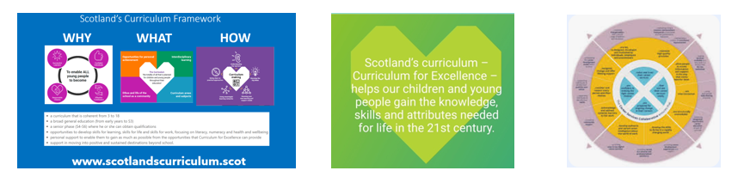

Defining the Problem
Our insights have told us that it is more than just policy that wants a cohesive and consistent approach to learner profile, with practitioners, parents, employers and young people all stating a need. We have also found that across Scotland many individuals and teams are spending time and money investing in a wide range of local products that re generally tied to an individual organisation. Apart from the wasted duplication, this means that the individual’s profile belongs to the establishment rather than to the individual and therefore does not travel with them as they transition through their learner journey.

The lack of consistency and cohesion in approaches causes additional issues in the system in that quality is variable in approaches with some young people missing out, institutions are not connected and speaking the same language to support learners, and the lack of national approach means that many are scrambling to define approaches in unfamiliar territory, which adds to workload and burden on the profession.

Co-designing with the National Co-design Group
Working in partnership with Education Scotland, a National Co-design Group was established in December 2022 with the aim of collaborating across the education and skills landscape to determine key issues in recognising the broad achievements of individual learners. This group has continued to evolve and support the work being undertaken, guiding the approach and solutions that are being established through co-design. The group meeting 4-6 times annually, with two in-person events taking place each year. The group has representation national, regional and local levels from a wide range of settings including SQA, SCQF, Youth Scotland, early years, primary and secondary schools, youth sector, community learning, local authorities, colleges and universities.

A draft paper was produced by the co-design group in May 2023 outlining the need for a joined-up approach to learner profile, definition of ambitions and principles, and some of the ingredients that would be expected within a digital profile. This has been a key reference for any subsequent activity.

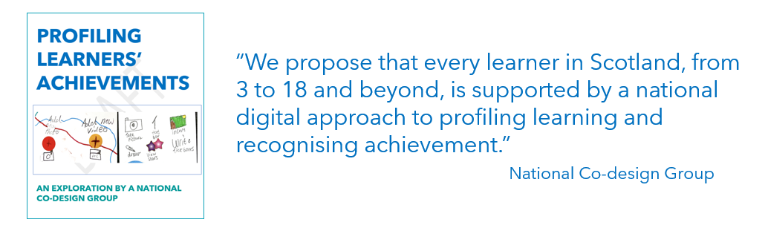

Co-designing with Learners
The approach to the digital profile has been to design with the learner from the outset. In January 2023, a specialist co-design agency was appointed to explore the learner problems and begin to co-design ideas and concepts in response to those defined user problems. This first wave of co-design work involved 13 co-design sessions, 9 schools/colleges across 7 local authorities, which involved 34 primary pupils, 48 secondary pupils, 9 college learners, 20 pupils with ASN. Also included 11 educators. This insight brought the wonderful and imaginative ideas that young learners had to life. We have continued with user insights and co-design practices to drive our approaches.

The delivery team is following a conventional and well-established approach for co-design taking us from user problem through to final solution for products we are developing. In doing so, there is a high degree of confidence that products we deliver will be intuitive, engaging and valuable for our customers.

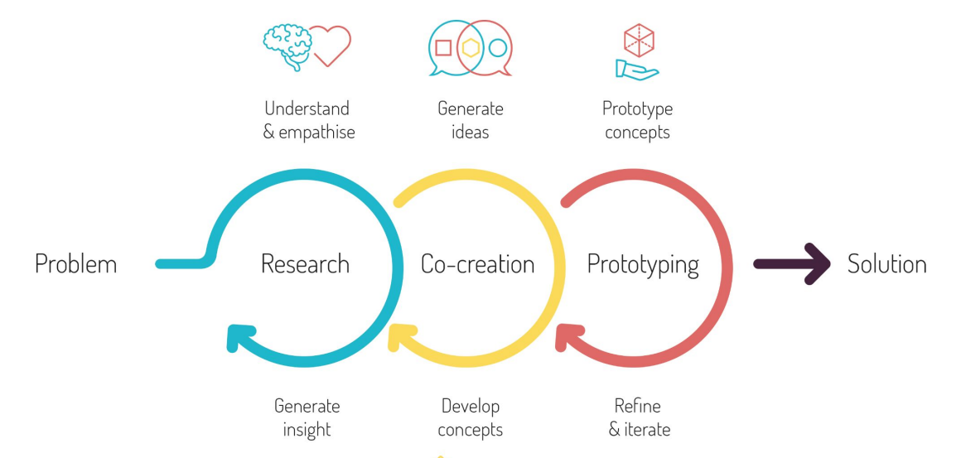

Young people can up with amazing ideas through the co-design sessions, some of which we would never have considered as a design team in isolation. Our products have been shaped through this creative thinking.

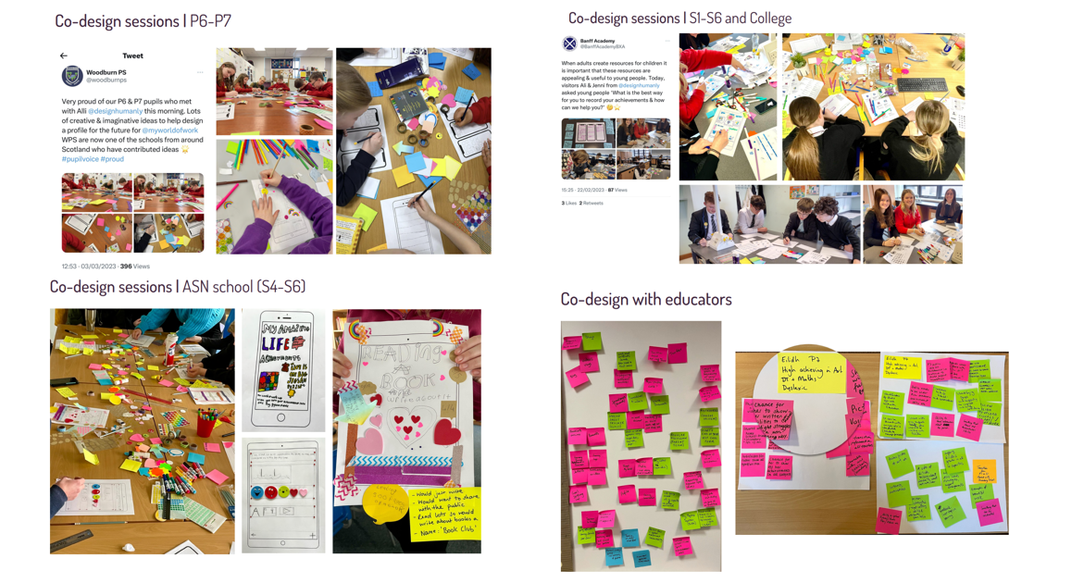

Transformation of Education Delivery
The Digital Profile will be a powerful tool, supporting a change in practice and pedagogy across Scottish education. There is large scale cultural changes and changes in practice within institution that need to be overcome for Profiling Achievements to be embedded and benefits to be fully realised. The profile in itself can be truly transformative.

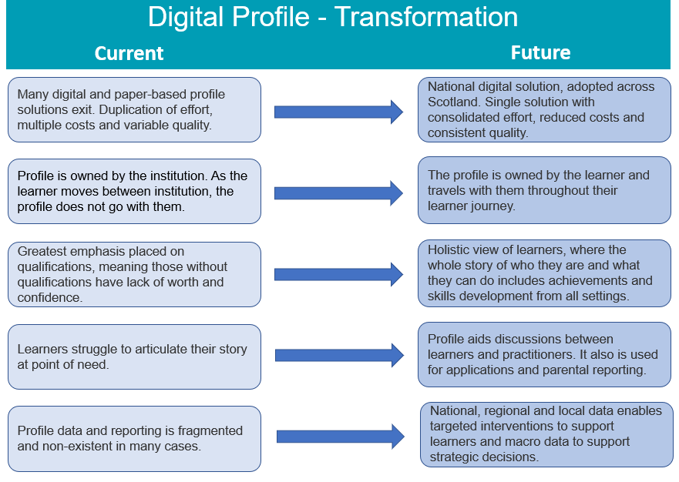
Working in partnership with Education Scotland, SQA and SCQF, a fortnightly working group has been established since summer 2023. In March 2024, the group agreed to structure the deliver under 4 key workstreams.
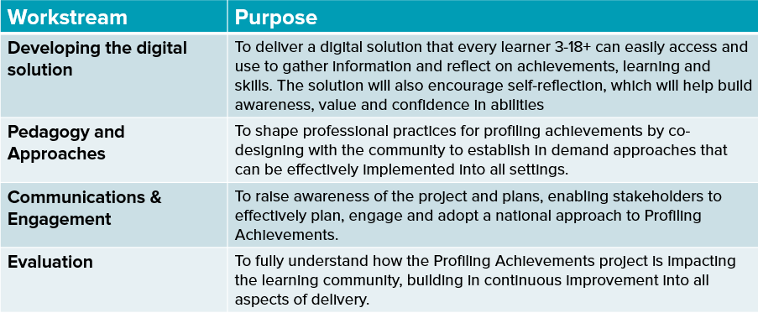

The Digital Profile will be launched at the end of 2024, available to all to trial and use in their organisation. Pilot authorities are being established in the coming weeks, which will likely be North Lanarkshire, Glasgow and Dundee. The National Co-design Group will also provide a wealth of feedback and insights from all settings. Additionally, a partnership agreement is in place with Youth Scotland to support awareness and engagement across the youth work settings, including close working relationships with the Youth Awards Network. The Evaluation and Research teams across Education Scotland and Skills Development Scotland are working in partnership to shape their approaches and will jointly report on findings.
The aim is that, from academic year 2025/26, all schools in Scotland will be able to adopt the Digital Profile with the key components in place to support mass uptake of the Digital Profile and resources in place to support practice change within individual institutions.

Who we have worked with as part of the national co-design group

The National Co-design Group has representation at national, regional and local levels from a wide range of settings including:
- Education Scotland
- SDS
- SQA
- SCQF
- Youth Scotland
- Gaelic Medium Education (GME)
- early years
- primary schools
- secondary schools
- youth sector
- community learning
- local authorities
- colleges
- universities
- employers

Co-designing with the National Co-design Group

Working in partnership with Education Scotland, a National Co-design Group was established in December 2022 with the aim of collaborating across the education and skills landscape to determine key issues in recognising the broad achievements of individual learners. Education Scotland wrote out to all 32 local authorities looking for volunteers that might be interested in discussions to move forward with approaches. 90 stakeholders attended the first session.

This group has continued to evolve and support the work being undertaken, guiding the approach and solutions that are being established through co-design. The membership was refreshed at the end of 2024 and continues to have approximately 90 people involved. The group meeting 4-6 times annually, with two in-person events taking place each year. The group has representation national, regional and local levels from a wide range of settings including SQA, SCQF, Youth Scotland, early years, primary and secondary schools, youth sector, community learning, local authorities, colleges and universities.

A draft paper was produced by the co-design group in May 2023 outlining the need for a joined-up approach to learner profile, definition of ambitions and principles, and some of the ingredients that would be expected within a digital profile. This has been a key reference for any subsequent activity.

2.0 Gathering Evidence and Assessing Impact

It is important to remember our responsibilities regarding the Public Sector Equality Duty when completing this section. The starting point for assessing impact is the three needs of the Public Sector Equality Duty: ensuring that the project does not discriminate unlawfully; considering how the project might better advance equality of opportunity; and considering whether the project will affect good relations between different groups.

Guidance for 2.0
The public sector equality duty is a duty on public authorities to consider or think about how their policies or decisions affect people who are protected equality characteristics under the Equality Act. If a public authority hasn't properly considered its public sector equality duty, it can be challenged in courts.
Tip- whilst going through each characteristic ensure you take some time to ask yourself the following questions:
- Does this project eliminate unlawful discrimination, harassment and victimisation and other conduct that is prohibited by the Equality Act 2010? If not, what can I change to ensure that it does eliminate unlawful discrimination, harassment and victimisation?
- Does this project advance equality of opportunity between people who share a relevant protected characteristic and those who do not? If it does you need to highlight this as a positive impact within your impact assessment.
- Finally, does this project foster good relations between people who share a protected characteristic and those who do not? Again, this should be highlighted as a positive impact.
The purpose of the IEIA is to allow you the space to identify areas for improvement; it is completely acceptable and appropriate to identify areas for improvement or places where there is unintentional discrimination. The important thing is that actions are identified and taken to mitigate.
There are multiple ways to approach this section. One is to consider how each group would be impacted at different stages of the project.
  - What issues might this group face in finding out about this project/opportunity?
  - What issues might this group face in accessing the project?
  - What other barriers might this group face throughout the delivery of the project?
  - How will you evaluate if this group has successfully been able to access the project?
  - Consider intersectionality within this too. For example, does a gay Muslim woman face additional barriers at each stage? Any mix of characteristics is appropriate to consider
Other prompts could include:
- What equality information have you accessed regarding:
  - Different needs?
  - Different experiences?
  - Different access to services, information or opportunities?
  - Different impacts/different outcomes? (for example, through project monitoring or data from similar projects, through internal/external research, statistics on local population)
- Are there any gaps in equality information that you will need to fill now/later?
- Are there any experts or people affected by the project you should consult now? (Include details of findings from consultation if this has already taken place)
- Who do you need to get views from, internally and externally? How will you ensure you include ‘harder to reach’ groups?
All these prompts can support all the questions within this section, but particularly Impact and Action. You do not need to use all the prompts; we have provided a range so that you can find the ones that suit your project best.

In Gathering Evidence and Assessing Impact you need to go through each of the characteristics in turn and address the following points.
- Provide Context – outlining how your project relates to this protected characteristic, such as population statistics. The Equality Evidence Hub is a good place to start looking for relevant evidence. The Equality Evidence Hub is a space on Connect to access relevant guidance for the IEIA and a range of equality evidence, both internal and external.

- Additional Questions- Some sections have additional questions, please ensure that you answer these appropriately. They are in reference to our reporting responsibilities for Children’s Rights and Wellbeing and Island Communities.

- Impact– Outline the potential disadvantage or barriers, as well as positive impacts, faced by this equality group in relation to this project. Cite evidence sources used, including consultation. Where a gap in evidence is observed, please note within this section.

- Action– Outline what we have already done to address disadvantage or promote equality, as well as what we’ll do to proactively promote equality and address any potential barriers raised in Evidence, including evidence gaps.
Please note that consultation is a requirement of Island Communities Impact Assessment and considered good practice in relation to Equality and Children’s Rights and Wellbeing Impact Assessments.

2.1 Age

Guidance for 2.1
Age can be considered within groups of ages, defined in a way that suits your project. Those at the younger and older ends of the labour market tend to face the most labour market disadvantages.

Context:
The profile is ultimately intended for all people in school and/or working age with the initial phases focussing on secondary school pupils.
This impact assessment will focus on the service for secondary school pupils and will be updated when the profile is being developed for all ages.

Impact (Does this project have a negative, positive or no impact? Please include the evidence of why that is, citing appropriate sources) | Action (What activity have you done already and what was the impact? What do you need to do to address the evidence?)
A positive impact on age is that the initial profile has been designed for secondary school pupils and the research and design has been based on this audience in order to be suitable for users needs. | When developing the profile extensive research and insight has taken place. This involved x number of stakeholders x number of pupils etc.  The impact of the insight with the audience is that we have designed something specifically for them.  Insight and usability testing with customers and non-users to fill any gaps in our knowledge as the project progresses.
The new legislation on the rights of the child will have a positive impact and is covered later in this document. | See Children’s Rights and Wellbeing section below.

2.2 Children's Rights and Wellbeing

See guidance for 2.2
This only applies to projects impacting young people up to the age of 18. If the project could impact on young people up the age of 18, you need to complete this section. There may be overlapping evidence, impact and action between Age and Children’s Rights. You can repeat or cite that it is present in Age and pertinent to Children’s Rights as well.

Please see the SDS UNCRC Report 2017-2022SDS UNCRC Report 2017-2022 for more information about how SDS is upholding the articles of the UN Convention on the Rights of the Child.

Context:
With a focus on secondary school pupils for the profile supports the United Nations Convention on the Rights of the Child (UNCRC). We have identified 17 articles that are of specific relevance to us. UNCRC has 54 articles that cover all aspects of a child's life. It entitles every child to claim them. It also explains how adults and governments must work together to make sure all children can enjoy all their rights.

Additional Questions:

Does this project impact on children and young people up to the age of 18?

☒ Yes ☐ No ☐ Don’t Know

If you have answered no to the question above, you do not need to complete the Children’s Rights and Wellbeing section of this form but please provide some justification for your decision below.

Which articles of the United Nations Convention on the Rights of the Child (UNCRC) (an international human rights treaty that grants all children and young people (aged 17 and under) a comprehensive set of rightsdoes this project impact on? See further guidance for this question

We’ve identified these articles which are most relevant:
- 2, 3, 5, 9, 12, 16, 19, 22, 23, 16, 5, 28, 29, 30 and 32

Impact (Does this project have a negative, positive or no impact? Please include the evidence of why that is, citing appropriate sources) | Action (What activity have you done already and what was the impact? What do you need to do to address the evidence?)
Article 3 Best interests of the child  The best interests of the child must be a top priority in all decisions and actions that affect children.  Article 12 Respect for the views of the child  Every child has the right to express their views, feelings and wishes in all matters affecting them, and to have their views considered and taken seriously. This right applies at all times, for example during immigration proceedings, housing decisions or the child’s day-to-day home life. | The purpose of the profile is to provide young people a space to document their progress through school and beyond so that they can make informed decisions on their future careers.  Insight, co-design and usability testing has been and will remain integral to the profile development.
Article 2 Non-discrimination  The Convention applies to every child without discrimination, whatever their ethnicity, sex, religion, language, abilities or any other status, whatever they think or say, whatever their family background.  Article 22 Refugee children  If a child is seeking refuge or has refugee status, governments must provide them with appropriate protection and assistance to help them enjoy all the rights in the Convention. Governments must help refugee children who are separated from their parents to be reunited with them.  Article 23 Children with a disability  A child with a disability has the right to live a full and decent life with dignity and, as far as possible, independence and to play an active part in the community. Governments must do all they can to support disabled children and their families.  Article 30 Children from minority or indigenous groups  Every child has the right to learn and use the language, customs and religion of their family, whether or not these are shared by the majority of the people in the country where they live. | All children have access to the tool to support their development and specific insight co-design and usability testing has taken place and will continue to do so with disabled pupils and pupils who are refugees.
Article 16 Right to privacy  Every child has the right to privacy. The law should protect the child’s private, family and home life, including protecting children from unlawful attacks that harm their reputation.  Article 32 Child labour  Governments must protect children from economic exploitation and work that is dangerous or might harm their health, development or education. Governments must set a minimum age for children to work and ensure that work conditions are safe and appropriate.  Article 19 Protection from violence, abuse and neglect (?)  Governments must do all they can to ensure that children are protected from all forms of violence, abuse, neglect and bad treatment by their parents or anyone else who looks after them. | This is what we do to ensure children’s information is safe:  https://www.myworldofwork.co.uk/privacy/  https://www.myworldofwork.co.uk/terms-and-conditions/
Adults (parents, care givers etc)  Article 5 Parental guidance and a child’s evolving capacities  Governments must respect the rights and responsibilities of parents and carers to provide guidance and direction to their child as they grow up, so that they fully enjoy their rights. This must be done in a way that recognises the child’s increasing capacity to make their own choices. | The parental role in the profile is still to be defined but parents will be involved in future phases.
Article 28 Right to education  Every child has the right to an education. Primary education must be free and different forms of secondary education must be available to every child. Discipline in schools must respect children’s dignity and their rights. Richer countries must help poorer countries achieve this.  Article 29 Goals of education  Education must develop every child’s personality, talents and abilities to the full. It must encourage the child’s respect for human rights, as well as respect for their parents, their own and other cultures, and the environment. | The purpose of the profile is to ensure equity and consistency for all pupils in terms of capturing and updating their skills and achievements.

2.3 Care Experience

See guidance for 2.3
Within SDS, we choose to use the term ‘care experienced’, by which we mean anyone who currently meets, or has ever previously met, the criteria for ‘looked after’. This includes those looked after at home, or away from home in kinship, residential, foster or secure care.

SDS is a Corporate Parent and we have public commitments within the SDS Corporate Parenting Plan - please ensure you are familiar with these commitments and ensure your project aligns as best as possible.

Context:
As a corporate parent Skills Development Scotland takes seriously the inequality in outcomes faced by care experienced people.
Care experienced pupils consistently obtain fewer qualifications than their non care experienced peers and are more likely to leave school at the age of 15 (or younger).
Care experienced students are underrepresented in higher education and face additional barriers to learning, including financial and housing problems.
Care experience individuals are more likely to be unemployed after leaving school and be in low-paid, low-skilled and part-time roles. Source.

Impact (Does this project have a negative, positive or no impact? Please include the evidence of why that is, citing appropriate sources) | Action (What activity have you done already and what was the impact? What do you need to do to address the evidence?)
There is a positive impact through links with care experienced (Who Cares Scotland Each and Every Child and STAF) and mainstream organisations (eg MCR Pathways) | The profile will continue to be developed to support care experienced customers with consideration to user journeys.  Insight, co-design and usability testing will continue to take place with care experienced young people to ensure that the profile is fit for purpose and the numbers of care experienced young people we work with will continue to grow.

2.4 Disability

See guidance for 2.4
Disability covers a wide range of conditions and impairments that impact people in a range of ways. You need to consider disability broadly and, in some circumstances, specific conditions/impairments. Within SDS we follow the Social Model of Disability, which says that people are disabled by barriers in society, not by their impairment or difference. The IEIA can support you to identify places where barriers still exist within your project and help to mitigate them.

Accessibility is a key point to reflect on regarding this characteristic. Here are some types of accessibility you may want to consider in your IEIA.

- Physical - is the physical space in use accessible to a range of people?
- Communication - Is the method of communication accessible? Have you considered British Sign Language and/or Easy Read (a specialist format that combines images with clear text. It is designed to help organisations communicate with people with a learning disability)?
- Time - Have you considered breaks and other considerations within an event to ensure autistic people have some time and space to decompress between presentations?

Context:
- In 2023, 37% of all pupils (259,036 individuals) had an additional support need (ASN).
- Around one fifth of Scotland's population – that’s one million people – define themselves as disabled. Yet disabled people often experience higher levels of inequality compared to their non-disabled peers. Source
- Only about 50% of disabled people of working age are in work compared to 80% of non-disabled people of working age.
- Employment rates vary greatly according to the type of impairment a person has. People with a mental health condition considered a disability have the lowest employment rate of all impairment categories (21%). The employment rate for people with learning disabilities is 26%. Source

Impact (Does this project have a negative, positive or no impact? Please include the evidence of why that is, citing appropriate sources) | Action (What activity have you done already and what was the impact? What do you need to do to address the evidence?)
The profile is intended to be used by all pupils. It is important that we extensively test the profile with people with diverse disabilities to ensure it is fit for purpose. This includes pupils with complex needs to understand if a profile solution can be found that would fit their needs. There could be a negative impact if we are excluding pupils with disabilities ability to use the profile. | Extensive insight and usability testing takes place with asn customers.  We are connected to the SDS disability focal point group.  Insight, co-design and usability testing will continue to take place with care experienced young people to ensure that the profile is fit for purpose and the numbers of care experienced young people we work with will continue to grow.
The categories we use to ensure we cover as many areas of disability as possible are as follows:  - Deafness or partial hearing loss  - Blindness or partial sight loss  - Full or partial loss of voice or difficult speaking  - Learning disability  - Learning difficulty  - Development Disorder  - Physical disability  - Mental health conditions  - Long-term illness, disease or condition  If we do not provide help and support for all our customers then they will not benefit from using the profile. | Ensure the website continues to be WCAG 2.2 AA compliant  Continue to ensure content meets legal requirements.  Continue to review and improve accessibility on the profile including usability testing with disabled customers and working with visually impaired and blind users to help us test the website with screen readers.  Work with BDA and other Deaf/deaf led organisations to provide video and review the journey with customers and a BSL plan for developing more videos for BSL customers.  Continue to look at how we can support our additional support needs and disabled customers and how this can fit with the technical restrictions of the profile.  Continued insight with asn and disabled audiences and where appropriate with their parents, carers, teachers and careers advisers.  Increase the amount of co-design/co-creation/user generated content with identified customer groups.  Continue to ensure any visual representations are inclusive.  New design system in place and regularly updated to ensure consistency for screen readers.  Continue to review the language level of content.  Identify specific groups within the disabled protected characteristic to focus on – starting with neurodivergent customers.  Continue to review best practice and adopt things like dyslexic fonts (if evidence shows they are more readable).  Review the accessibility and create a report on overlays (for translating and font colours etc).

2.5 Gender Reassignment

See guidance for 2.5
Gender Reassignment is sometimes more commonly referred to as transgender. For more information about the characteristic of Sex, please see guidance in that section.

Please note that data around gender reassignment/transgender frequently includes information around sexual orientation as well. You may have data that cuts across Sexual Orientation and Gender Reassignment. However, they are distinct characteristics.

Please note that data may be limited for this characteristic due to small sample sizes.

Context:
Young trans people experience high levels of bullying and harassment at school and at higher levels than LGB+ young people impacting upon schooling experiences.
Trans students are more likely to continue to have negative experiences of education at further or higher education levels. Moving from school to college or university can be a difficult time for trans young people due to reduced support networks.
Trans people may experience specific barriers when both looking for and staying in work. Trans workers are more likely to experience workplace harassment and discriminaton than the wider LGB population. Source.

Impact (Does this project have a negative, positive or no impact? Please include the evidence of why that is, citing appropriate sources) | Action (What activity have you done already and what was the impact? What do you need to do to address the evidence?)
There could be a negative impact if the language used on the site is not gender neutral. Pronouns are currently included in the profile. | Regularly monitoring language on the profile.  Sessions with trans and non binary people have taken place in the past – it would be good to have a regular session to review content and look at creating content.  Work with trans organisations to identify trans people to conduct insight and usability testing with.
Insight sessions have taken place with trans customers | Continue insight and usability testing with trans customers.  Increase the amount of co-design/co-creation of relevant content

2.6 Marriage/Civil Partnership

See guidance for 2.6
This characteristic should only be considered in reference to SDS as an employer. Most IEIAs will not need to cover this characteristic.

Context:
Marriage and Civil Partnership are only protected characteristics in regards to employment. It is not felt that there is an equality impact for the profile to consider.

Impact (Does this project have a negative, positive or no impact? Please include the evidence of why that is, citing appropriate sources) | Action (What activity have you done already and what was the impact? What do you need to do to address the evidence?)
No action required on marriage/civil partnership required on the profile at this time.

2.7 Pregnancy and Maternity

See guidance for 2.7
The Equality Act protects individuals from discrimination when they are pregnant until their right to maternity leave ends and they return to work or if they do not have the right to maternity, two weeks after the child is born.

Context:
Teenage pregnancy rates in Scotland are at their lowest rate since 1994 but the impact of pregnancy for school-aged girls remains far-reaching. Teenage mothers are less likely to finish their school education with long-term implications for restricted education and career opportunities.
Student mothers at universities experience various issues arising from the dual and often conflicting roles of being both a mother and a student, including stress, guilt and anxiety along with financial difficulties.
The motherhood pay penalty results in women earning 28% less than before having children when they return back to the workplace. Good quality, convenient, reliable and affordable childcare is key to facilitate mothers’ re-entry and retention in the workforce. Source.

Impact (Does this project have a negative, positive or no impact? Please include the evidence of why that is, citing appropriate sources) | Action (What activity have you done already and what was the impact? What do you need to do to address the evidence?)
There is no existing content related to pregnancy and maternity on the profile. | No action required on pregnancy/maternity is required on the profile at this time – but this can be reviewed as required.

2.8 Race

Guidance for 2.8
In the Equality Act, race can mean your colour, your nationality (including your citizenship or your ethnic/national origins, which may not be the same as your current nationality.) (https://www.equalityhumanrights.com/en/advice-and-guidance/race-discrimination)

Context:
Ethnic minority groups in Scotland have higher participation rates and progression to higher education than white groups. Pupils from ethnic minority backgrounds tens to have higher levels of attainment.
Outcomes for BAME students differ by ethnic background with white British students having better outcomes in terms of degree attainment and potential future earnings. BAME students tend to have less work experience related to their courses before starting university and are less likely to have undertaken a placement or internship.
Despite high levels of attainment in education, ethnic minority individuals in Scotland are not experienced the same labour market advantages as their white counterparts. The ethnicity pay gap in Scotland is 10.3%
Ethnic minority individuals are disproportionately more likely to work in low-paying sectors and less likely to hold managerial or senior positions in business. They are also more likely to be self-employed. Source.
Different races and gypsy traveller etc

Impact (Does this project have a negative, positive or no impact? Please include the evidence of why that is, citing appropriate sources) | Action (What activity have you done already and what was the impact? What do you need to do to address the evidence?)
There should be no negative impact on race with the profile tool itself. | Insight has taken place with BME customers.  We are connected to the SDS race focal point group.  Identifying groups within race that are most disadvantaged and creating groups to explore further (eg.Gypsy traveller and African young people) would be beneficial.
Insight has taken place to review content  Language is considered with content tested for a reading age of 9 (for customers who have English as a second language). | Continue to ensure representation is diverse in any imagery.  Review content and consider if the language could be made simpler.  Continued insight and usability testing with ethnic minority customers  Increase the amount of co-design/co-creation with ethnic minority customers with specific focus on identified groups that are most adversely affected.

2.9 Religion or Belief

See guidance for 2.9
Religion or belief refers to both religious and some non-religious beliefs, as well as the lack of belief.

Another important consideration in this characteristic is Islamophobia, which “is rooted in racism and is a type of racism that targets expressions of Muslimness or perceived Muslimness” (definition from All Party Parliamentary Group on British Muslims paper entitled Islamophobia Defined)

Context:
There is limited data on religion or belief in education.
Limited evidence is available on the relationship between employment and religion or belief. However, evidence does suggest that Muslim workers are at a disadvantage as they have lower wages are more likely to be unemployed and that Muslim women face even more disadvantages and struggle more in the labour market. Source.

Impact (Does this project have a negative, positive or no impact? Please include the evidence of why that is, citing appropriate sources) | Action (What activity have you done already and what was the impact? What do you need to do to address the evidence?)
There is risk of negative impact if there are no visibly Muslim imagery and/or rights information for rights in employment for different religions. | Ensure diversity of imagery.  More insight with Muslim customers.

2.10 Sex

See guidance for 2.10
The Equality and Human Rights Commission provided the following guidance regarding the characteristic of sex.

“Under the Equality Act 2010, ‘sex’ is understood as binary, being a man or a woman. For the purposes of the Act, a person’s legal sex is their biological sex as recorded on their birth certificate. A trans person can change their legal sex by obtaining a Gender Recognition Certificate. A trans person who does not have a Gender Recognition Certificate retains the sex recorded on their birth certificate for the purposes of the Act.”

https://www.equalityhumanrights.com/en/advice-and-guidance/what-equality-act-says-about-protected-characteristics-sex-and-gender

Context:
Girls continue to outperform boys in qualification attainment and positive post school destinations. School subjects chosen are still heavily segregated by gender.
More young women than men go into FE and he where subject choice continues to be gender imbalances, impacting upon future career opportunities.
Women are affected by low pay, precarious employment and continuing gender pay gaps. Women are under-represented in entrepreneurship, yet women-led businesses perform slightly better than male-led or mixed-led businesses.
Economic inactivity rates are higher for working aged women than men and the inactivity rate continues to rise as a long-term post-pandemic legacy. The main reasons include caring for family/home and long-term sickness for women compared to predominantly long-term sickness for men. Source.

Impact (Does this project have a negative, positive or no impact? Please include the evidence of why that is, citing appropriate sources) | Action (What activity have you done already and what was the impact? What do you need to do to address the evidence?)
There is a positive impact in terms the online profile tool being gender blind so job suggestions are not gender bias. | Extensive insight and usability testing took place with genders of all ages for the launch of the beta website. We provide information on additional support needs eg rights, support available, funding for women returners.  Connected to the SDS Women and Girls focal point group.  Monitor and review imagery of women across the site.
Language is reviewed by the content team to ensure it is gender neutral | Continue to monitor and review language on the profile.

2.11 Sexual Orientation

See guidance for section 2.11
Please note that data around sexual orientation frequently includes information around trans individuals as well. You may have data that cuts across Sexual Orientation and Gender Reassignment. However, they are distinct characteristics.

Context:
At school, bullying based on sexual orientation negatively affects educational attainment and career plans of LGB+ students. Many LGB+ young people in the UK encounter challenges in schools such as bullying, isolation and lack of support which negatively impacts their ability to engage in education.
College and university are generally considered to be more positive environments for LGB+ individuals compared to school, with lower incidences of bullying and harassment.
However at university the lack of structure and unchecked homophobic biphobic and transphobic behaviour can have a negative impact on the mental heath attendance of ability of LGB+ students to finish their degrees.
LGBT+ individuals can face challenges in the workforces such as experiences of anti-LGBT+ abuse and language, gendered workplaces that are not LGBT+ inclusive and poor mental health support.
In the workplace barriers can remain in the form of harassment and discrimination for LGBT_ workers and a significant proportion of LGB+ employees have hidden or disguised their sexuality to avoid discrimination. Source.

Impact (Does this project have a negative, positive or no impact? Please include the evidence of why that is, citing appropriate sources) | Action (What activity have you done already and what was the impact? What do you need to do to address the evidence?)
Insight sessions have taken place with LGB+ customers | Continue insight co-design and usability testing with LGB+ customers.  Increase the amount of co-design/co-creation of relevant content for the profile as appropriate.

2.12 Poverty

See guidance for 2.12
Poverty can be defined in several ways:

• Geography based – Poverty can be measured by geography. The Scottish Index of Multiple Deprivation (SIMD) ranks Scottish postcodes between 1-10 to indicate how deprived the area is. This ranking is based on a range of factors, including average education levels of residents, crime levels, and housing quality (see SIMD, 2020). In this document SIMD 1 = most deprived and SIMD 5 = least deprived.

• Income – Income is widely used as an indicator for individual or household poverty. Households in the UK are classed as living in poverty if they are 60% below the median household income (Scot Gov, 2017).

• Occupation – The job that an individual has can be categorised hierarchically. The ‘NS-SEC’ measurement fits occupations into a scale of occupational prestige, which also broadly captures levels of pay too.

Context:
Children living in poverty are less likely to be able to read well at school than their classmates. 1 in 5 children from poor families in Scotland leaves primary school unable to read well, a level four times as high as that of pupils from better off households. Not reading well can cut short children’s chances in life and makes Scotland less fair and less prosperous. This is despite the best efforts of government, teachers and families around the country. Source
The impact of poverty on digital inclusion is startling and leads to an increased digital divide.

Impact (Does this project have a negative, positive or no impact? Please include the evidence of why that is, citing appropriate sources) | Action (What activity have you done already and what was the impact? What do you need to do to address the evidence?)
Steps have been taken to make the profile ‘greener’ which has a knock on effect of making the site use less mobile data | Continued work will take place on the website to ensure loading times are minimised.  Testing to discover if we can implement a 3G speed for loading to assist customers with poor connectivity
Insight usability testing and co-design sessions have taken place with customers in areas of deprivation | Continue insight and usability testing with customers from deprived areas.  Work with partner organisations such as the Poverty Alliance  Ensure insight takes place across areas of deprivation and insight and usability testing is conducted with youth groups as well as in schools to ensure diversity.
Access to individual devices for pupils is patchy across local authorities and individual schools – in cases where there is still only an IT suite in schools added to lack of mobile phone ownership or mobile data there would be a negative impact for individuals. This may be exacerbated in rural areas and island communities. | It would be useful to gain an overview of which schools in Scotland still only have IT suites as a starting point to understanding the scale and helping to address this issue.
Access to opportunities may vary from area to area and from household to household. This could be seen as a negative in terms of the profile due to inbuilt societal inequity but could also be used to identify areas where profiles are less populated due to fewer amenities and resources. | Monitor the achievements section and map to areas to identify patterns around lack of opportunities available.

2.13 Island Communities

See guidance for section 2.13
The Islands (Scotland) Act 2018 was passed by the Scottish Parliament in 2018 and is only one of a handful of place-based pieces of legislation to focus specifically on islands in the world.

The measures it contains, like the Island Communities Impact Assessment, are designed to meaningfully improve outcomes for island communities. The provisions in Sections 7 to 14 of the Act came into force on 23 December 2020. For more in depth guidance from Scottish Government, please follow this link (https://www.gov.scot/publications/island-communities-impact-assessments-guidance-toolkit-2/)
The Additional Questions below cover steps 1-5 of the ICIA. The questions under Full Island Community Impact Assessment cover steps 6, with step 7 covered later in the IEIA form.

In December 2019, Scottish Ministers published the first-ever National Islands Plan, which was created with the input of many islanders and those with a strong interest in Scotland's islands. The Plan sets out thirteen Strategic Objectives which will also be critical over the next five years to improving the quality of life for island communities. When you are developing your project, it is important that you consider the National Islands Plan.

Context:
. According to the Islands (Scotland) Act 2018 (https://www.legislation.gov.uk/asp/2018/12/enacted), an island community means a community which, "consists of two or more individuals, all of whom permanently inhabit an island (whether or not the same island), and is based on common interest, identity or geography (including in relation to any uninhabited island whose natural environment and terrestrial, marine and associated ecosystems contribute to the natural or cultural heritage or economy of an inhabited island)." Island Community Impact Assessments are a relatively new requirement, so published evidence may be difficult to obtain at present. However the ICIA focuses on consultation as a key form of evidence, so please consider gathering evidence via this method, particularly if you cannot identify existing evidence.

Island Engagement for Learner Profile

Additional Questions:

Does this project include, deliver or impact on Island Communities (a community which consists of two or more individuals, all of whom permanently inhabit an island and is based on common interest, identity or geography)?
☒ Yes ☐ No

Is this a project, which is likely to have an impact an island community which is significantly different from its effect on other communities (including other island communities) in the area?

☐ Yes ☒ No ☐ Don’t know

If you have answered no to the two questions above, you do not need to complete any further questions in the Island Communities section of this form but please provide some justification for your decision below.

From the beginning of the project the islands have been included in its development with workshop sessions and co-design sessions happening in Shetland and Skye with young islanders educators and youth organisations. Island communities have also been involved from the start in the national co-design group.

What island community concerns are you already aware of?
  - Opportunities
  - Connectivity
  - Access to devices

Does the existing data for Island Communities differ between islands?
No

Are there any existing design features or mitigations in place? If yes, please describe
Consideration for more insight rurally and from island communities – specifically with Youth Scotland and their Young Islander cohort. Look at further engagement with Highland and island communities for insight codesign and usability testing. Continue to listen to communities through the national co-design group.

If you are consulting, is your consultation robust, meaningful, and demonstrating that SDS has regard for island communities when carrying out its functions?

Guidance
Remember to consider whether it is appropriate to conduct consultation in Gaelic as well as English. You can email islands@sds.co.uk for advice regarding consultations in Gaelic.

Yes – see above.

Impact (Does this project have a negative, positive or no impact? Please include the evidence of why that is, citing appropriate sources) | Action (What activity have you done already and what was the impact? What do you need to do to address the evidence?)
The impact is positive and will continue, | More insight usability and co-design with island communities. Explore how we do this remotely and how we can tap in to other project that are happening. Continue to grow relationships through the national co-design group.

Please complete the following questions after the impact assessment above.
Does the evidence show any different circumstances, expectations, needs, experiences or outcomes (such as levels of satisfaction or participation)?
☒ Yes ☐ No

Are these different effects likely?
☒ Yes ☐ No

Are these effects significantly different?
☒ Yes ☐ No

Could the effect amount to disadvantage for an island community compared to the mainland or between other groups?
☒ Yes ☐ No

If the answer is no to all of the above, please provide justification for not completing the full ICIA below.
There is no evidence that the online profile tool itself will impact greater on island communities than that of the mainland. However, insight and representation will continue and the results may lead to a full ICIA in future.

If the answer is yes to any of the above, complete the Full Island Community Impact Assessment below before submitting the form for publication
Full Island Community Impact Assessment

Assess the extent to which you consider that the project can be developed or delivered in such a manner as to improve or mitigate any resulting outcomes for island communities.

Consider alternative delivery mechanisms and whether further consultation is required.
As well as the in person session we will tap into existing networks and see how we can work remotely with these audiences.

Describe how these delivery mechanisms will improve/mitigate outcomes for island communities?
Greater understanding of the specific issues for island communities will be factored in.

Identify resources required to improve/mitigate outcomes for island communities.
Sessions in person and remotely online.

Should delivery mechanisms/mitigations vary in different communities?
More research is required.

Do you need to consult with island communities in respect of mechanisms or mitigations?
Not over and above the planned sessions

Have island circumstances been factored into the evaluation process?
Yes – as above.

Have any island-specific indicators/targets been identified that require monitoring?
No

How will outcomes be measured on the islands?
As above – through continued involvement from educators youth group sand young people through schools.

How has the project affected island communities?
Not as yet

How will lessons learned in this ICIA inform future project making and service delivery?
They will continue to be monitored over time.

2.14 Rural Communities

See guidance for 2.14
There is likely to be substantial overlap between island communities and rural communities. You do not need to replicate impact and action from island communities into rural communities. It is important to consider where rural communities may differ from island communities, and this section should be used to highlight those differences, if they exist or to consider rural communities where a project does not impact on island communities but does impact rural communities.

Context:
Rural Scotland is based on the Scottish Government’s Rural and Environment Science and Analytical Services (RESAS) classification of rural areas. It covers the Aberdeenshire, Angus, Argyll and Bute, Clackmannanshire, Dumfries and Galloway, East Ayrshire, East Lothian, Na h-Eileanan Siar, Highland, Moray, Orkney Islands, Perth and Kinross, Scottish Borders, Shetland Islands, and South Ayrshire local authorities. The 15 local authorities above are those RESAS classified as either ‘mainly rural’ or ‘islands and remote rural’.
Scottish Government defines rural Scotland, "as settlements with a population of less than 3,000. A settlement is defined to be a group of high density postcodes whose combined population rounds to 500 people or more. They are separated by low density postcodes.
By analysing drive times to larger settlements we can divide rural Scotland into:
Accessible rural: those with a less than 30 minute drive time to the nearest settlement with a population of 10,000 or more; and
Remote rural: those with a greater than 30 minute drive time to the nearest settlement with a population of 10,000 or more. (https://www.gov.scot/publications/rural-scotland-key-facts-2021/pages/1/)

Opportunities for apprenticeships and jobs are fewer rurally
Wages tend to be lower rurally.
People may have to be more pragmatic about their options based on opportunities locally.
Public transport issues can present more of a problem to attend FE and HE which particularly affects people living in poverty

Impact (Does this project have a negative, positive or no impact? Please include the evidence of why that is, citing appropriate sources) | Action (What activity have you done already and what was the impact? What do you need to do to address the evidence?)
Rural communities are consulted and collaborated with through the national co-design group remote sessions with schools | More insight usability and co-design rurally. Explore how we do this remotely and how we can tap in to other project that are happening.

2.15 Other

See guidance for 2.15
This section is optional and can be used if you feel there are any other specific groups that you would like to assess (for example, carers, armed forces/veterans and those with experience of the justice system)

Context:
People with lived experience of the prison system and veterans are two groups that have been identified as disadvantaged in terms of future employment opportunities – these are not audiences that will be affected by the profile – although some insight with young offenders and the staff in those institutions may be useful.

Impact (Does this project have a negative, positive or no impact? Please include the evidence of why that is, citing appropriate sources) | Action (What activity have you done already and what was the impact? What do you need to do to address the evidence?)
Both groups are more likely to be adults and so not included in this equality assessment | There is scope to work with young offenders through partner organisations and explore opportunities for insight, co-design and user generated content with this group to ensure the profile is suitable for them.

2.16 Consultation Recording
Consultation is an excellent source of evidence and can offer insight that cannot be gathered in any other way. It is important to be well prepared when consulting with partners, ensuring you do not take too much of their time and that you efficiently gather the information you need. However, it is also easy to over consult with our partners, so sharing key learning is important to mitigate that risk. It is also important to inform your consultees about changes that have been made (or not made) based on their input. Please use this space to share key learning from your consultations and how you have fed back to the consultees.
Further information on our National Approach to Equality Stakeholders can be found here.
Focal Point Groups can also be useful for consultations, further information can be found here.

See guidance for 2.16
Scottish Government suggests that consultation should adhere to the following principles:

- Continuous – Stakeholder engagement and consultation should begin as early as possible and continue until your proposal is complete.
- Broad-Based – Consideration of the scope of consultation about your proposal should be wide enough to include all those affected and ensure a full spectrum of diversity in views and opinions.
- Not Burdensome – Timeframes for consultation should be realistic and should not impose additional unnecessary workloads on organisations or people who may be expected to respond to multiple consultations over a period. This could result in "consultation fatigue" and may reduce the quality of the responses you receive.
- Transparent – You should outline the objectives of your consultation and the context surrounding your proposal. All relevant supporting information should be made available.
- Consistent and Flexible – Use of a consistent framework for consultation allows respondents to become familiar with the process and can negate concerns for respondents in relation to fatigue from responding to numerous different frameworks.
- Subject to Evaluation and Review – Consultation processes should be evaluated, reviewed and updated as a means towards continuous improvement.
- Defined Goals – Consultations should be "a means rather than an end". They should be used as a means of informing decision-making rather than a substitute for decision-making.

Stakeholder(s) consulted | Key feedback from stakeholder(s) | What changes were made based on the feedback? (if none, explain why) | How was this fed back to stakeholders? (including date provided)
All 32 local authorities have been consulted. | Consultation insight and co-design | Changes were made to the profile based on feedback from schools | Schools were made aware of changes based on their inputs.
Youth groups in all local authorities | Consultation insight and co-design | Changes were made to the profile based on feedback | Youth groups were made aware of changes based on their inputs.
Colleges in all local authority areas | Consultation and insight | Changes were made to the profile based on feedback | Colleges were made aware of changes based on their inputs
Partners in all local authority areas | Consultation and insight | Changes were made to the profile based on feedback | Partners were made aware of changes based on their inputs.
ASN in all local authority areas | Consultation insight and co-design | Changes were made to the profile based on feedback  changes were made based on the feedback? (if none, explain why) | Additional support needs schools were made aware of changes based on their inputs
Care experienced in all local authority areas | Consultation insight and co-design | Changes were made to the profile based on feedback | People were made aware of changes based on their inputs
YEMP (young ethnic minority people) in all local authority areas | Consultation insight and co-design | Changes were made to the profile based on feedback | People from the session were made aware of changes based on their inputs

3.0 Action Plan

A key part of every impact assessment is the action plan. This is where you state the actions that you will take in response to the impact assessment you have completed. The actions should be specific, measurable, achievable, relevant and timebound (SMART).
Once the IEIA has been signed off by the SRO, actions within the Action Plan should be added to the relevant team’s Continuous Improvement Action Plan.

See guidance for 3.0
Consider the following points when drafting actions:
- How will you monitor the action and ensure it will be completed?
- If you are taking an action regarding Equality Monitoring, have you ensured it is compliant with GDPR legislation?
- If you have taken actions related to procurement, how will you ensure these are reflected within procurement documents and contracts?

What is the action you will take in response to the impact assessment? | Which characteristics/groups does it apply to? | What is the intended impact? | When will this be completed?
Insight co-design and usability testing with customers and non-users to identify gaps in our knowledge focussing on the gaps in our knowledge. | All except marriage/civil partnership: Age (older and younger at point of profile development for those age groups), Disability (focus on asn neurodivergent customers) Religion: Muslim, Transgender, LGB+ | Provide a service for all customers | For launch and ongoing
Exploration on if there are any features that can be added to assist with viewing the profile product around preference setting as well as how this could be rolled out in public access centres. Continue to review the accessibility and created a report for overlays (for translating and font colours etc). | Age/disability/digital poverty | Provide a service for all customers | For launch and ongoing
Continue to ensure photography/imagery/illustrations are diverse and ‘real’ as appropriate | All except marriage/civil partnership | Provide a service for all customers | For launch and ongoing
Language is considered | All except marriage/civil partnership | Provide a service for all customers | For launch and ongoing
Ensure the website continues to be WCAG 2.2 AA compliant and ensure we meet legal requirements. | Disability | Provide a service for all customers | For launch and ongoing
Explore if we can update the general video on My World of Work services in BSL to include the profile. | Disability | Provide a service for all customers | Autumn 2025
Continued insight co-design and usability testing with audiences and where appropriate with their parents, carers, youth workers community learning and development workers educators and careers advisers resulting in improvements to meet the needs of all our audiences. | All except marriage/civil partnership | Provide a service for all customers | For launch and ongoing
Identify specific groups within the protected characteristic to focus on | Disability (neurodivergent customers),Race (Roma and gypsy traveller, muslim, black African) and future areas identified to do insight with, co-design and usability test | Provide a service for all customers | For launch and ongoing
Continue to look at how we can support our additional support needs and disabled customers and how this can fit with the technical restrictions of the platform – including complex needs. | Disability | Provide a service for all customers | For launch and ongoing
Continue to connect to the SDS focal point groups. | Race, care experienced, women and girls, disability | Provide a service for all customers | For launch and ongoing
Work with local authorities to understand local digital needs are being met for those who do not have personal access to digital devices. | Poverty | Provide an equitable service regardless of location or household income. | For launch and ongoing
Provide the data to local authorities and school to enable them to shape the curriculum and provide opportunities to those in need. | Poverty | Provide an equitable service regardless of location or household income. | For launch and ongoing
Work with Youth Award Network to engage with young people from island communities | Island communities | Understand unique needs of young islands in relation to achievements and profile | For launch and ongoing

4.0 Approval and Publication

- Will you be making this IEIA available in different formats/languages?

Guidance
Scottish Government specifically asks about making impact assessments available in Easy Read and Gaelic within their guidance for the Island Community Impact Assessments. It is not required, but they do suggest it is considered. You can email islands@sds.co.uk for advice regarding publication in Gaelic.

On request

SRO (Print) | SRO Signature | Date | Review Date
David Grier | 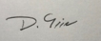 | 29/07/2025 | 30/07/2026

5.0 Review (To be completed at the review date, not at the same time it is submitted)

This section should be completed as part of the review on the date listed above under the sign off.

Guidance for 5.0
Reviewing is important for several reasons.
- It will allow you to reflect on progress and learning before completing an updated IEIA in the future.
- If you do not need to complete an updated IEIA, it stills allows for evaluation of the project and can provide learning for others in the future who are developing similar/related projects.
- It will help the equality teams to identify and share good practice across the business.

Were the actions taken completed? If not, why not?

Did the actions achieve what they intended? If not, why not?

What actions would you continue/stop or reconsider for future projects?

Has any evidence been identified that may be useful for similar future projects?

If this is a review for an ongoing project, are there any additional actions to add to the project going forward?

