
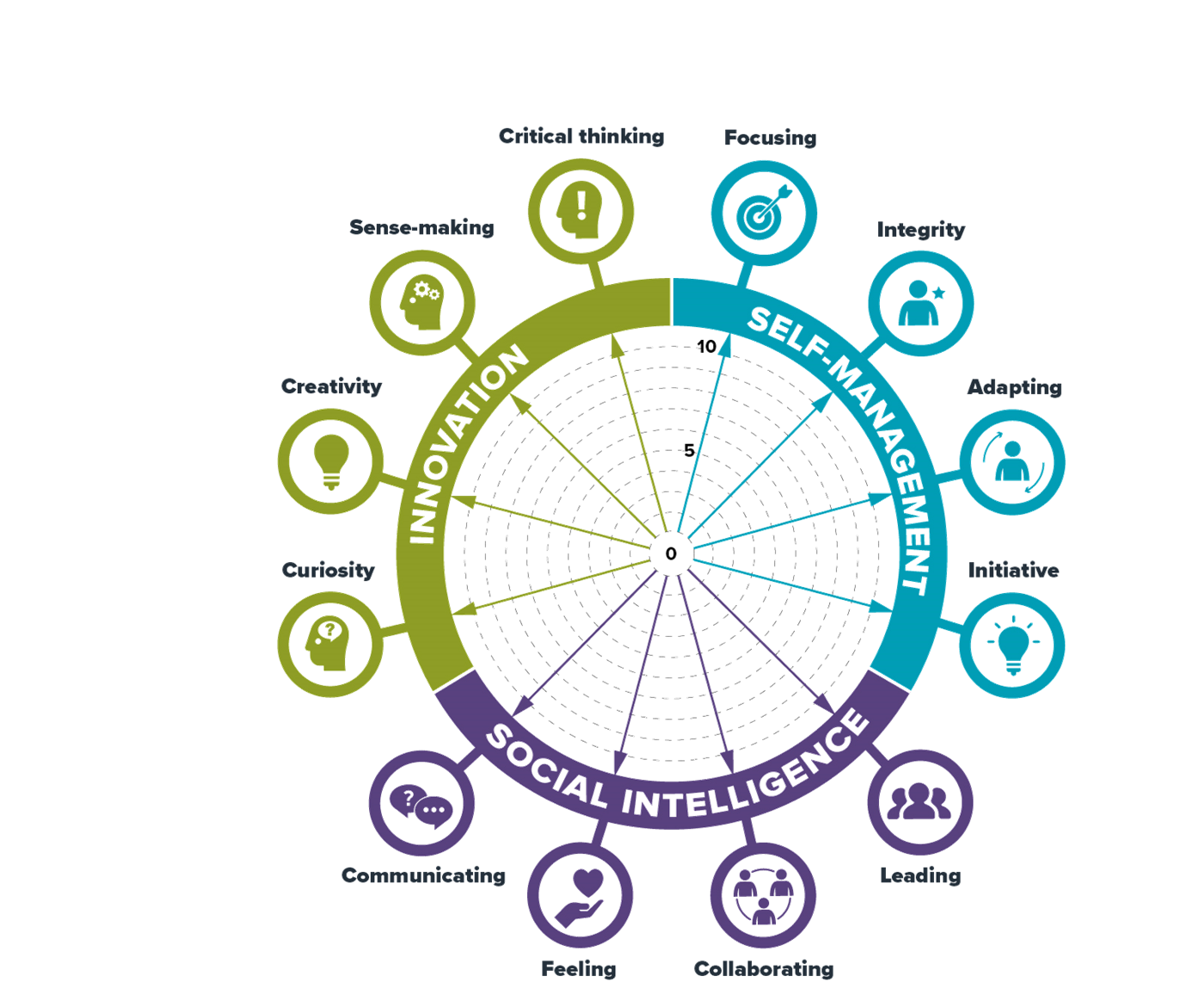
Self-evaluation wheel

How to use the wheel:

- Please read the guidance document and use the suggested questions in the guidance to support
your conversations with apprentices.
- There are separate work sheets for each of the broad headings for meta-skills
  - Innovation
  - Self-management
  - Social intelligence

Apprentices can use these worksheets to support their reflection with their development of meta-skills.
They can be adapted to include everyday language and terminology appropriate to your apprentices.
We have included examples of everyday terms in this document to support your discussions
about meta-skills in practical workplace contexts. The wheel can be revisited over time, and completed
worksheets should be retained and used as portfolio evidence of the Apprentices meta-skills development

Step 1

- Taking each meta-skill in turn
- Plot yourself on the arrow with a dot:
  - 0 = not confident/areas to develop
  - 10 = very confident/accomplished in this area
- Use the questions on the worksheet to capture the evidence about ‘why’
you have placed yourself at each point
- Join up each of the dots once you have completed all of them

Step 2
Looking at your completed wheel, take time to reflect on the following questions:
What do I notice?
- What meta-skills stand out as areas of strength?
- What meta-skills do I need to focus on improving?
- How might these areas impact on each other?

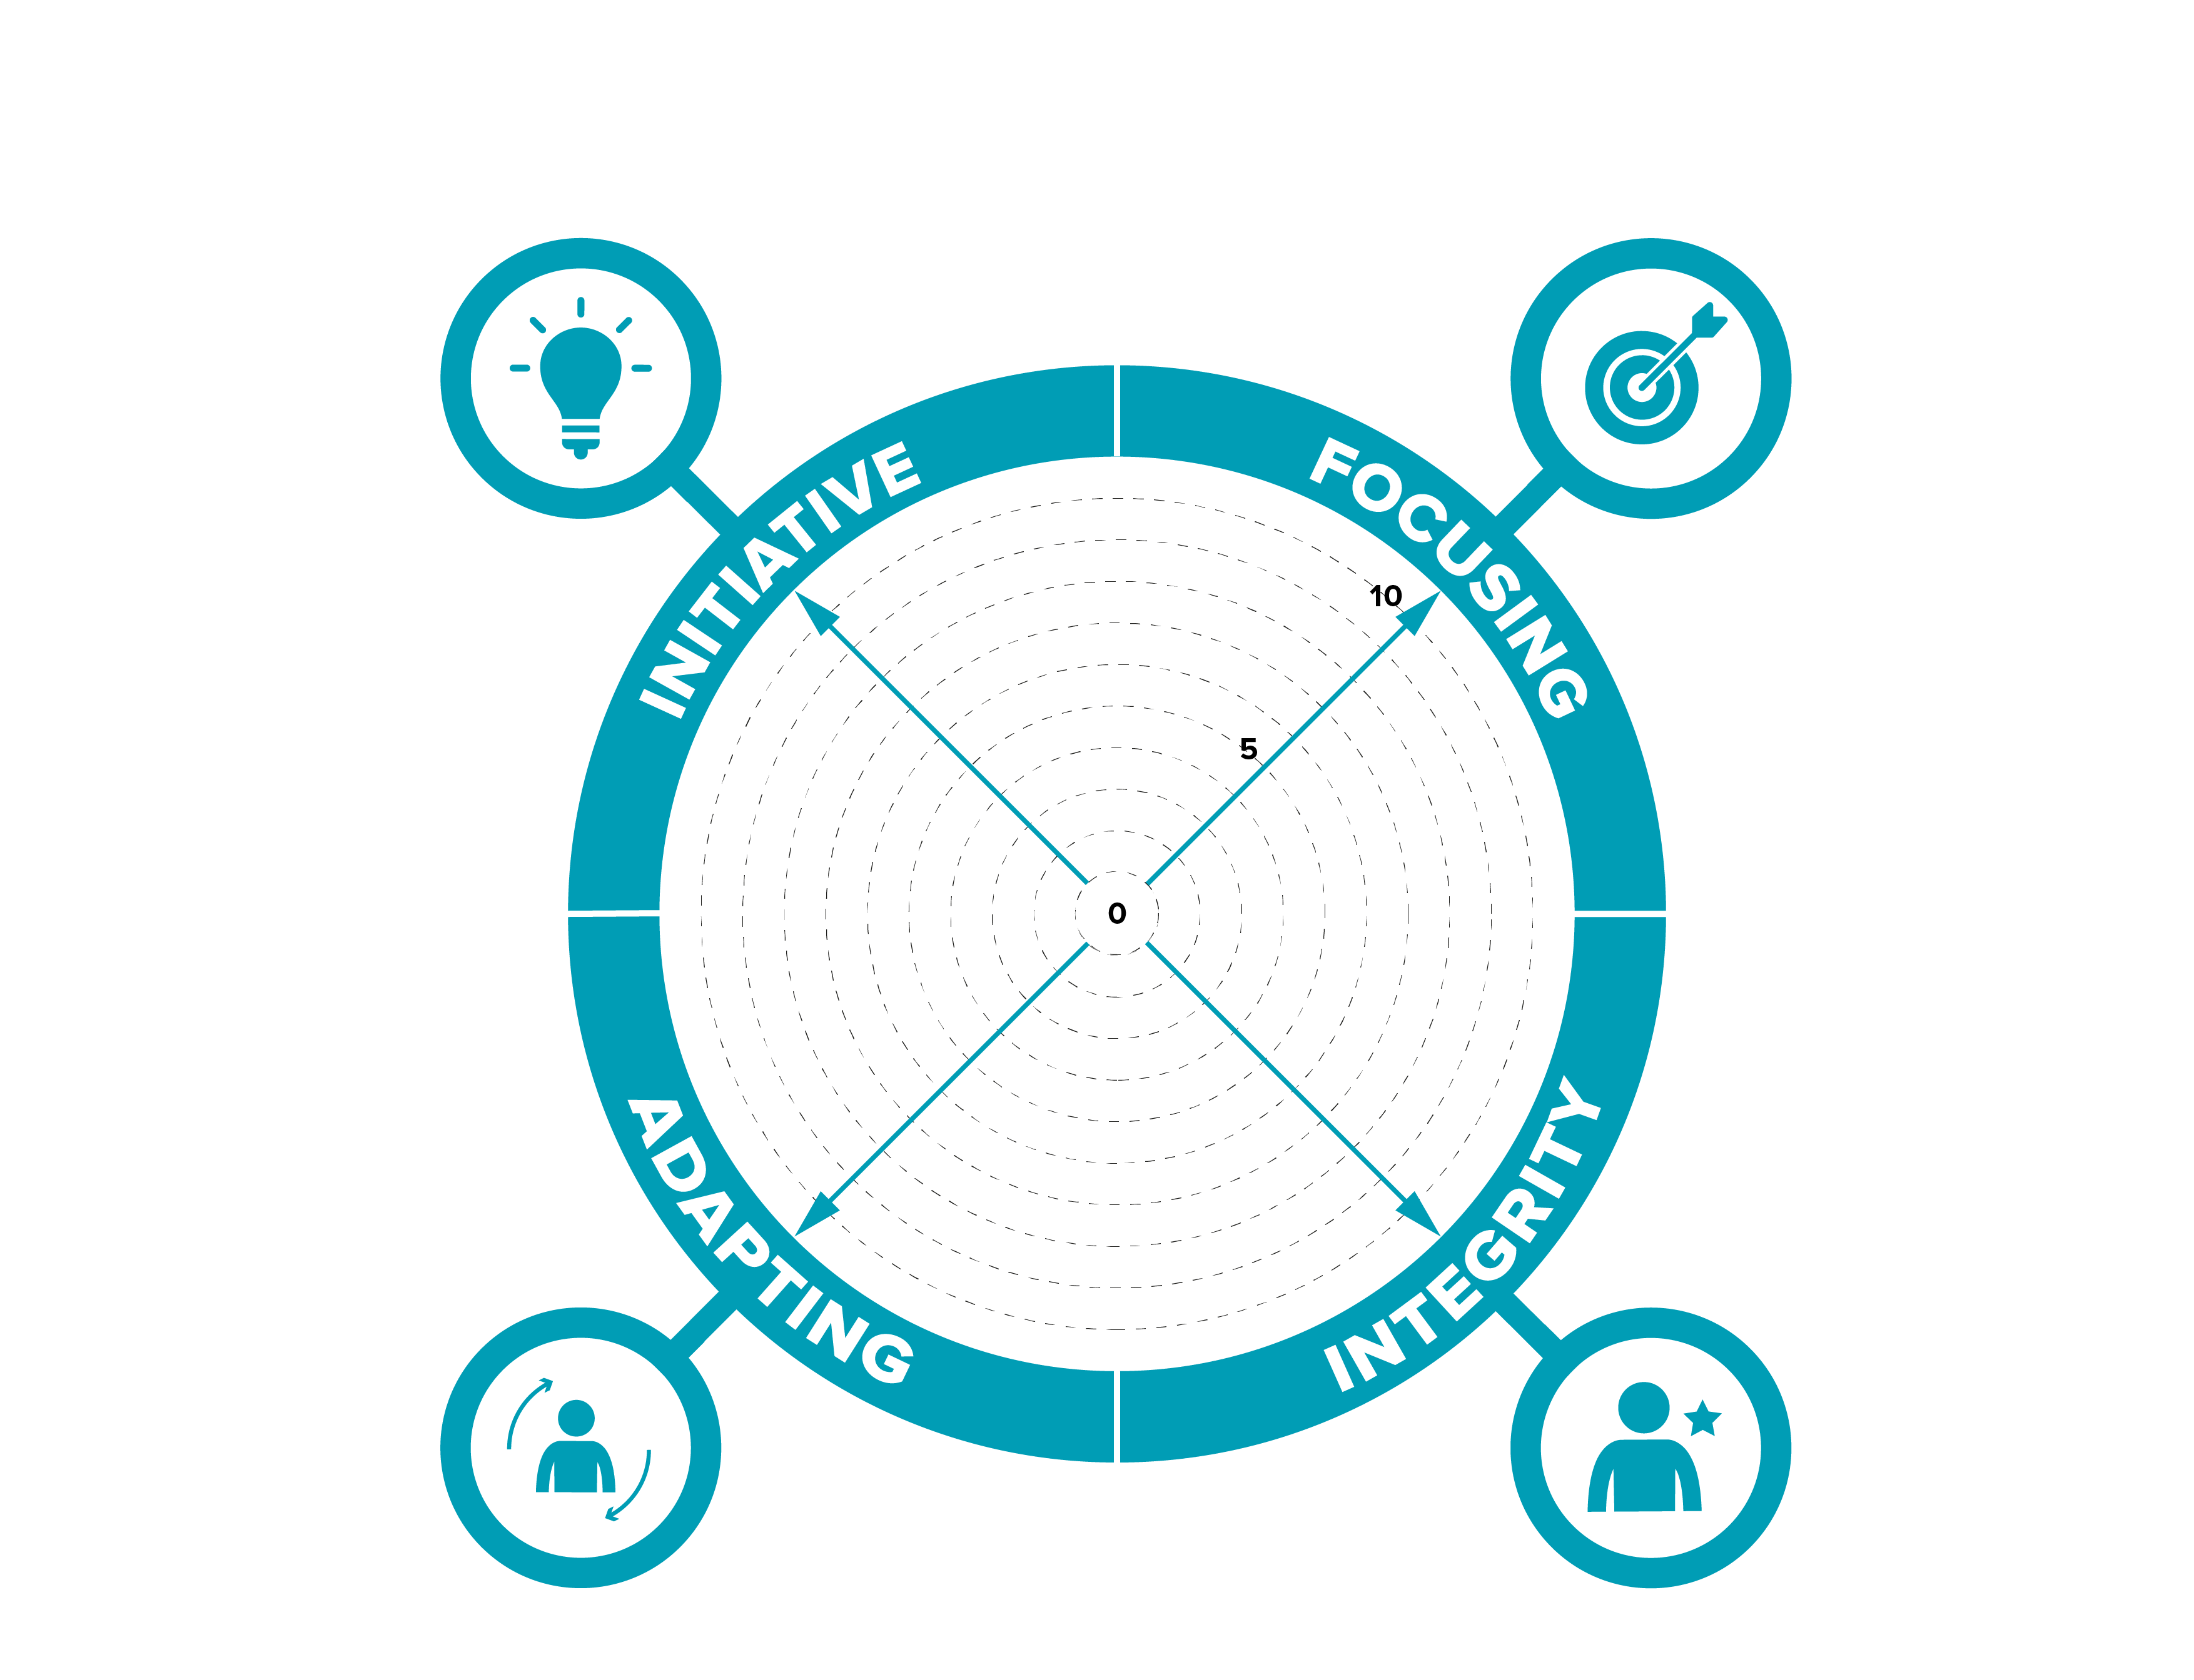

Self-evaluation wheel
How to complete this worksheet:
- taking each meta-skill in turn
- Plot yourself on the arrow with a dot: 0 = not confident/areas to develop
10 = very confident/accomplished in this area
- Under each question capture examples that evidence ‘why’ you have placed yourself at each point

How well do you think for yourself?

SELF-MANAGEMENT
Can you concentrate on what’s important?

How well do you adjust to change?
How well do you stay true to yourself?

Self-evaluation wheel

How to complete this worksheet:

- taking each meta-skill in turn
- Plot yourself on the arrow with a dot: 0 = not confident/areas to develop
10 = very confident/accomplished in this area
- Under each question capture examples that evidence ‘why’ you have placed yourself at each point

How well do you express yourself and
share information?

Do you understand how other people
are feeling?

How well do you lead by example and
Inspire and motivate others?

How well do you work with other people?

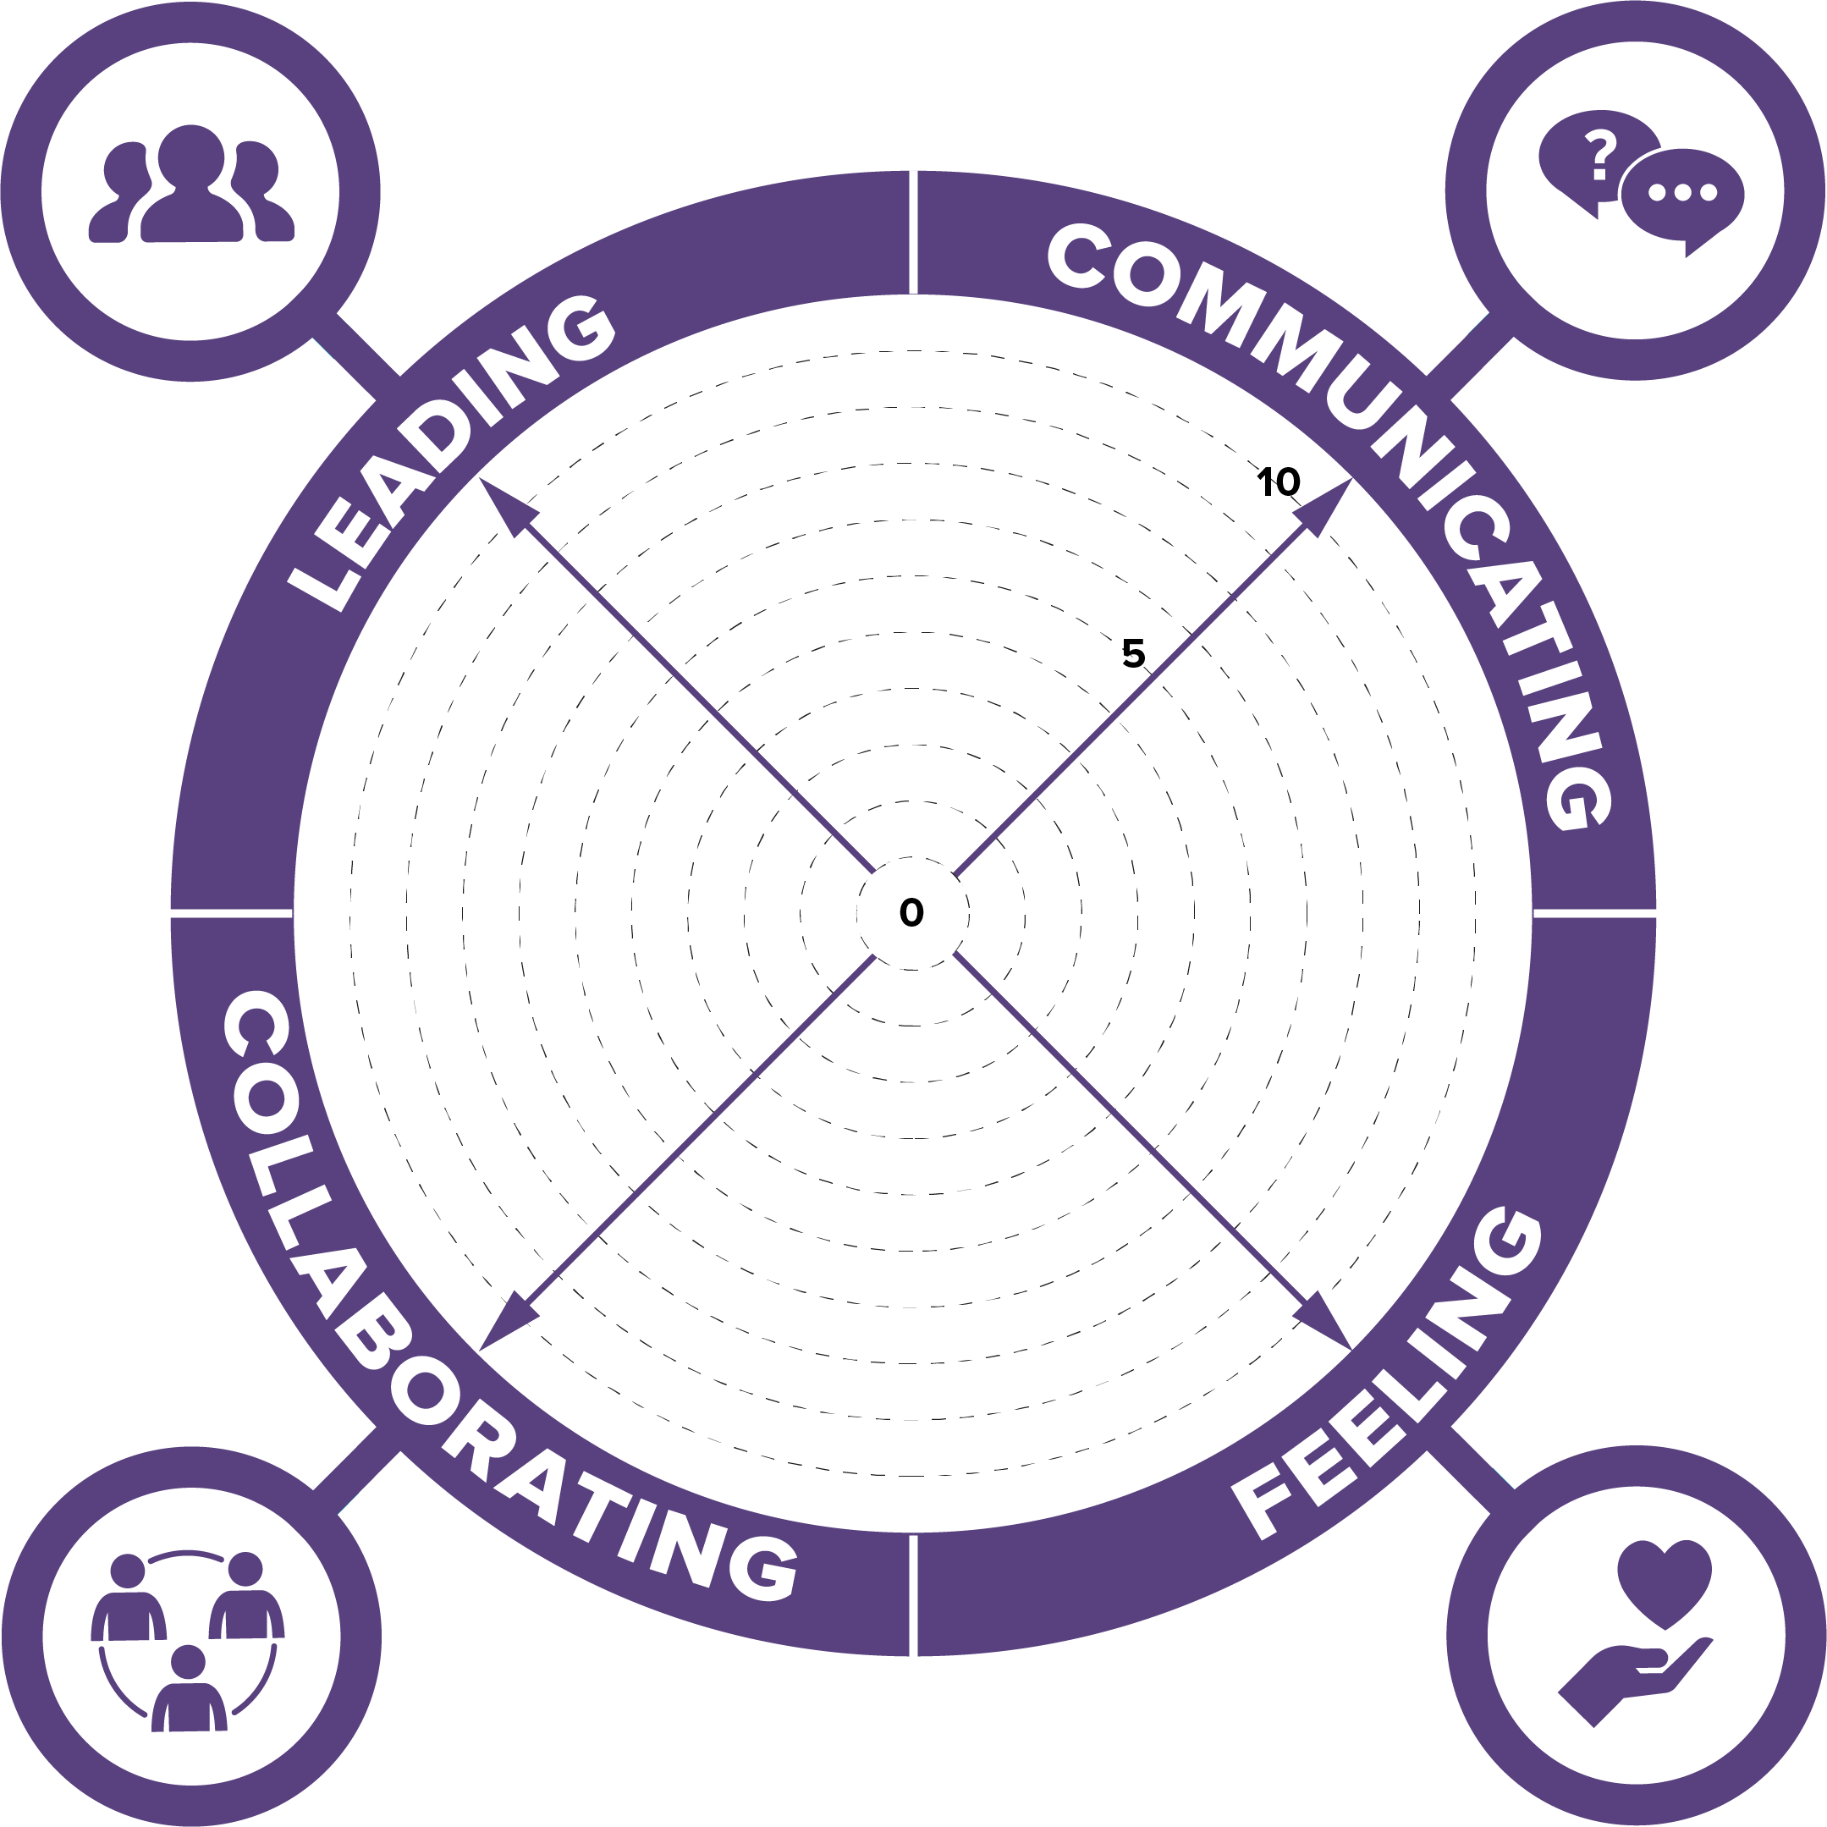
SOCIAL INTELLIGENCE

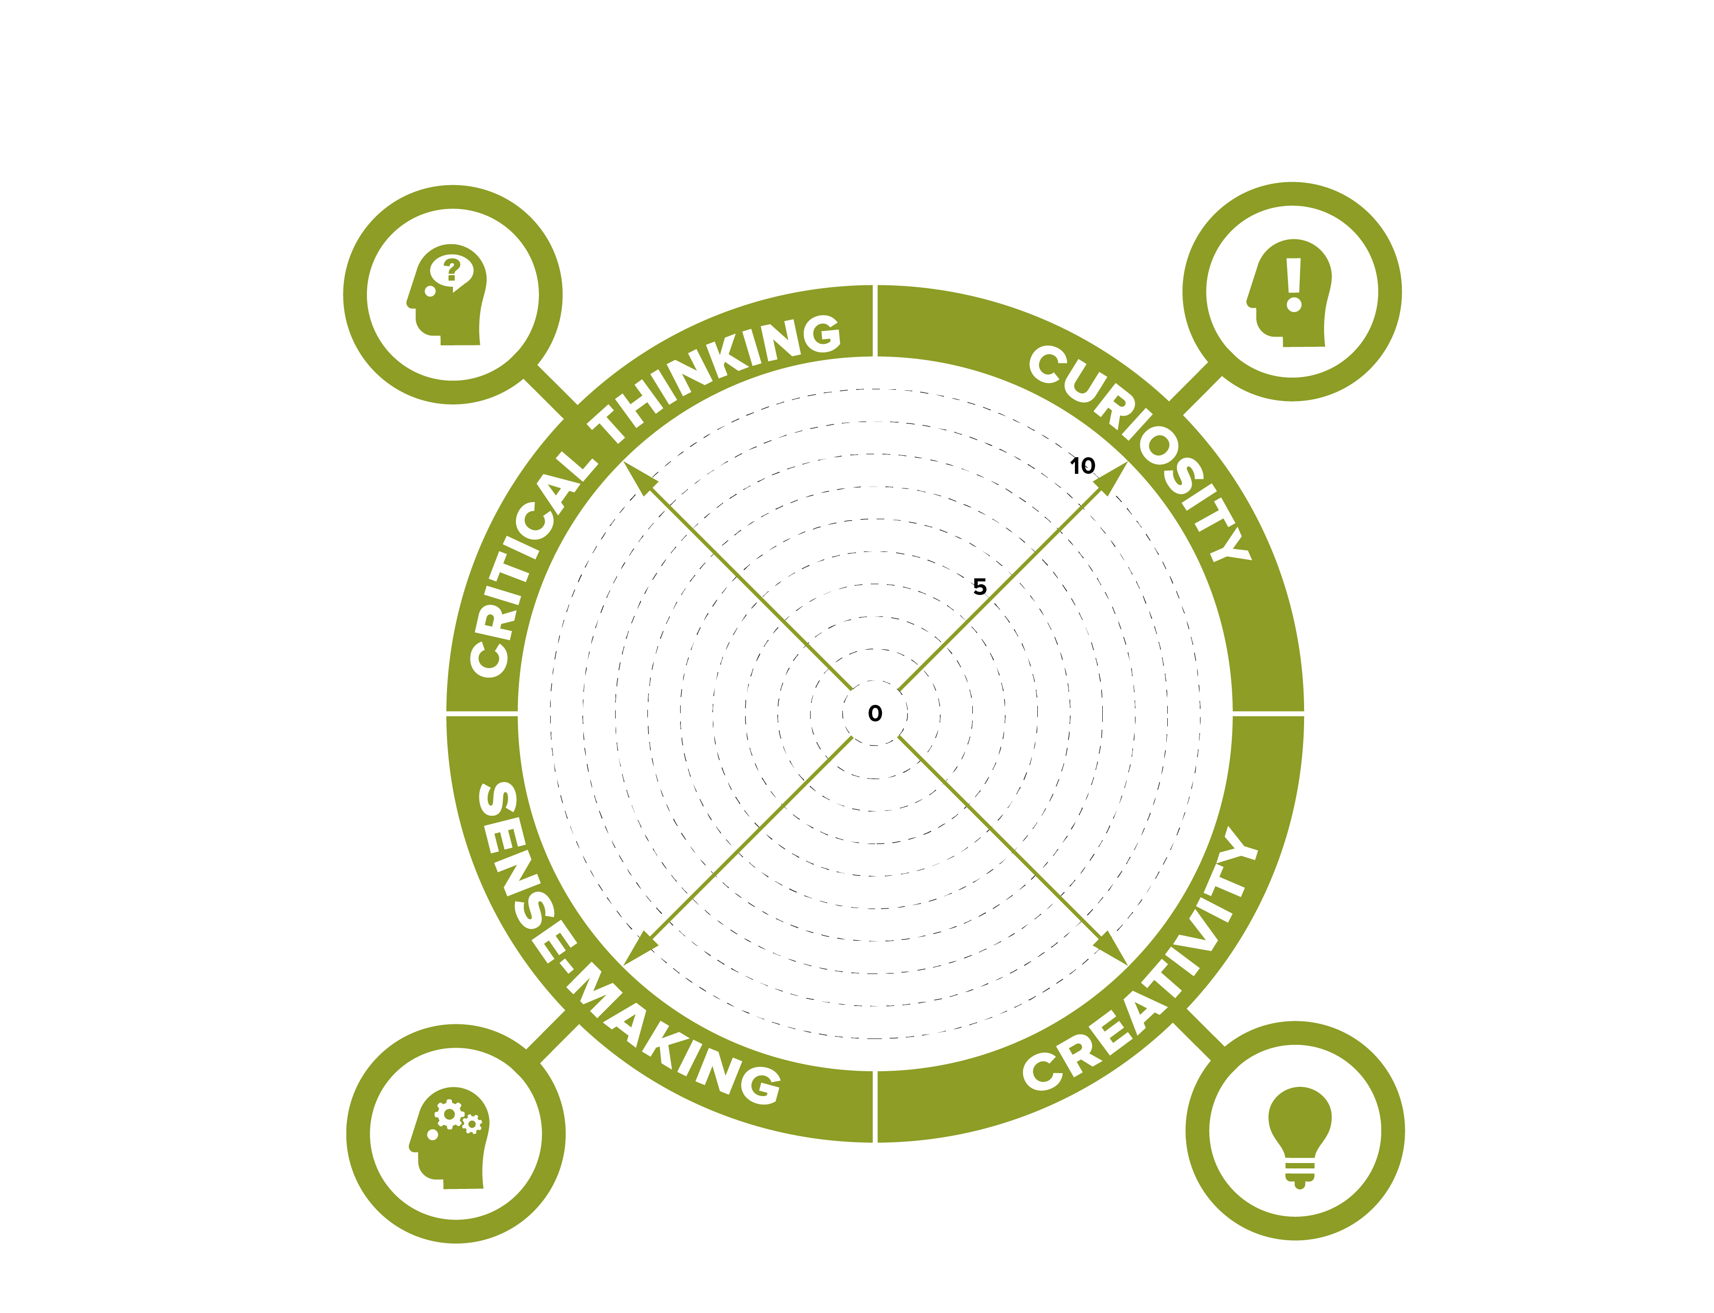
Self-evaluation wheel

,
How to complete this worksheet:
- Taking each meta-skill in turn
- Plot yourself on the arrow with a dot: 0 = not confident/areas to develop
10 = very confident/accomplished in this area
- Under each question capture examples that evidence ‘why’ you have placed yourself at each point

How do you think and evaluate information?

How do you recognise patterns in things around you?

INNOVATION
How good are you at asking the right questions?

Can you think for yourself and think of new ways to do things?

