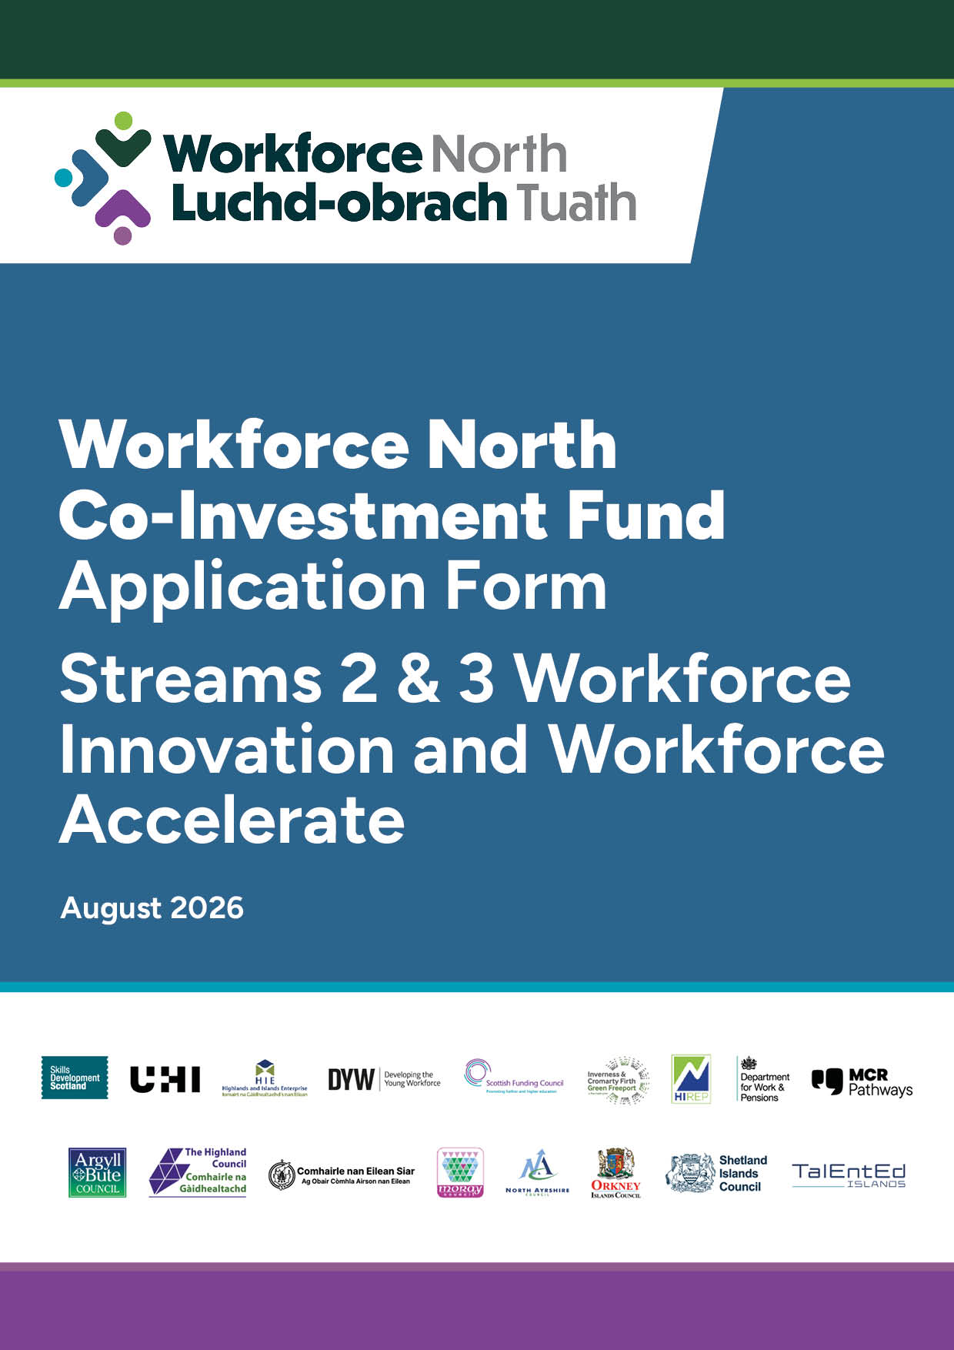


Co -Investment Fund
APPLICATION FORM B: Stream 2 Innovation & Stream 3 Accelerate

Important Instructions
General
- Please refer to the Stream 2 & 3 Specific Guidance and the General Guidance including the scoring.
- Please save this application form on your computer before starting to complete.
- Please ensure that all questions are answered and that any documents requested are provided.
- If you have any questions in completing this application, please email WFN@highland.gov.uk
- Please submit applications to WFN@highland.gov.uk

Section 1: Lead Applicant Details
  - Business Details
Business Name:
Business address (registered office):

Please confirm which of the WFN Local Authority area’s you function within | Argyll & Bute  Comhairle nan Eileen Siar  Moray Council  Orkney Islands Council  Shetland Islands Council  The Highland Council  The Islands of Arran and Cumbraes (North Ayrshire) | ☐  ☐  ☐  ☐  ☐  ☐  ☐
Address (Local Office in WFN geography):

Website:
Company Registration Number:
UTR (HMRC Ref)

  - Business Structure
Sole trader | ☐
Partnership | ☐
Limited company (if yes, please provide registration number) | ☐
Social enterprise | ☐
Other | ☐
Is your company VAT registered? | Choose an item.
How many Full Time Equivalent (FTE 35 hours per week and above) employees do you have?

  - Applicant Contact Details (They must have a good knowledge of this application)
Forename(s) |  | Surname
Position in Business:
Address (if different than the above):

Phone number/s:
Email address:
Does the main contact have any communication needs? E.g. textphone, sign language, large print? Choose an item.
If yes, what are they?

1.4 Bank Account details – must be used for business purposes only
Bank:
Account Name:
Sort Code:
Account Number:

Section 2: Your Application
2.1 Which Funding Stream are you applying to? Choose an item.
2.2 Are there any Partner Organisations involved with the delivery of the project:
Choose an item.
If yes, please list
Delivery Partner | Business Structure | Company Registration  (if applicable)
 | Choose an item.
 | Choose an item.
 | Choose an item.
 | Choose an item.

2.3 Have you communicated with your Local Authority regarding your application?
Choose an item.
If yes, please provide the name of who you communicated with.

2.4 Please describe your project and include:
- How the project links to the WFN Stream
- How it links to the priority sectors
- Type of support, e.g. upskilling existing employees, new employees through pathways, specific programme for unemployed
- Target number of qualifications aimed for and justification for these targets
- Role of each Delivery Partner (if applicable) and how dependencies will be managed
- Any other wider partners involved e.g. Local Employability Partnerships

You are also required to complete Annex A (Excel Sheet) Targets - See Section 4, Finance.
It is mandatory to complete the excel sheet to allow the application to proceed.

Text box will expand as required

2.4.1 Employer led demand and challenge definition: Please provide a clear statement of the workforce problem being addressed through this application
- Evidence of demand, e.g. vacancies, pipeline gaps, sector needs
Text box will expand as required

2.5 Implementation and Readiness to Deliver
Please provide a timetable to describe how you will implement the Project. Detail clear and dated milestones for delivery. Details to include:
- Development phase (if applicable)
- Actual delivery start date
- Delivery end date
- Other relevant project milestones, examples could be and depending on type of project proposal, contracts issued, contract start date, induction of trainees, anticipated date of qualifications started, different project phase start and end dates
Text box will expand as required

2.6 Risk & Compliance
Please describe:
- How you will manage risks of delivery and who has ownership of the risks and whether you have a risk register?
- Your fraud controls
- How you manage Data Protection
- How you monitor the above?
Text box will expand as required

2.7 Stream 2: Innovation ONLY Evaluation and Scalability
How will you evaluate the success of the project, please describe the approach you will take. Please describe how the model, if successful might be scalable for roll-out:
Text box will expand as required

2.8 Stream 3: Accelerate ONLY
Please describe evidence of a provide approach, including:
  - Past Performance of the proposed model
  - Scaling plan
  - Reach across sectors/geographic WFN areas
  - Demand
Text box will expand as required

Section 3: Subsidy Control
Has your business received financial support which you have been notified as a subsidy that has been received or is currently awarded to you within the last three years? |  |  | Choose an item.
If yes, please complete the table below:
Date the support was received | What was the support for? | Who was it from? | How much was the support for?
 |  |  | £
 |  |  | £
 |  |  | £
 |  |  | £

Section 4: Finance
From the completed excel spreadsheet (below), please provide a summary of the grant requested. Please refer to General Guidance and Stream 2 & 3 Guidance.
Total  Cost | WFN Seed Fund Grant Requested | Total Contribution  from LA  (if applicable) | Total from  Private Sector
£ | £ | £ | £

Please complete attached Annex A. It is mandatory to complete the excel sheet to allow the application to proceed. Once completed, please ensure you click the Save button in Excel before submitting your application.
4.1 Please explain by the WFN Grant is required:
  - Explain why no other funding routes cannot cover the costs
  - What would happen without the grant support?
  - Confirm no double funding

Text box will expand as required

4.2 Please provide a summary of how the costs outlined within Annex A have been reached. Include justification for the costs.

Text box will expand as required

Section 5: Declaration & Checklist
5 Attachments
As well as this form, please confirm you have submitted the following:
Your most recent annual accounts (a link can be provided) | Choose an item.
A bank statement of less than three months old showing bank account name, account number and sort code and matching the details provided within the application form. All balances can be detracted | Choose an item.

5.1 Declaration

We confirm that we are allowed to submit this application on behalf of:

Name of organisation

We undertake to ensure that all the necessary enclosures are included, that the information is, to the best of our knowledge, accurate and that this application complies with the eligibility guidance.

The data you have provided in the application and claim forms will be recorded on an electronic database and are subject to the provisions of the Freedom of Information Act (Scotland) Act 2002, the Data Protection Act 1998.

Under the Data Protection Act 1998 and in accordance with the GDPR 2016, we need your consent to share personal information about your organisation with organisations. Please confirm, by ticking the box below you have read and accept the Privacy Notice Terms, available to view on the Workforce North Co-investment Fund webpage.

I confirm ☐

Signatory 1
Print Name: | Signature: | Date:
Role in Organisation

