

**Right to Work Immigration Documents**

For all New Scots groups staring work, including Modern Apprenticeships, should have a share code which they would share with employers/ training providers to check their right to work.

1. **Ask the applicant for a 9-digit alphanumeric share code** (starts with ‘w’) generated from their eVisa account, and their date of birth.  
   1. If you are helping the applicant, they should go to: [View your eVisa and get a share code to prove your immigration status online](https://www.gov.uk/view-prove-immigration-status)

Training providers to check their right to work on: [Check a job applicant’s right to work](https://www.gov.uk/view-right-to-work).

* 1. If the applicant is unable to access their eVisa account, they might still have a Biometric Residence Permit (BRP) card which they generate a share code from. They should use: [Prove your right to work to an employer](https://www.gov.uk/prove-right-to-work/get-a-share-code-online).   
       
     With the share code and date of birth, training providers would use the same: [Check a job applicant’s right to work](https://www.gov.uk/view-right-to-work).
* After entering the applicants share code and date of birth, there are few screens with questions e.g. company name, and you should then see the applicants profile (example below) indicating any restrictions in the area of work they can do and ‘**details’** such as the limit to how long they can stay in the UK.   
    
   A screenshot of a computer

  AI-generated content may be incorrect.

1. **If the applicant is unable to generate a share code**, for example due to an error with the online system, they may have other [immigration documents](https://www.gov.uk/prove-right-to-work/using-immigration-documents) e.g. a passport with a Home Office ‘endorsement’ or a letter issued by the Home Office indicating the application for leave to enter/remain.

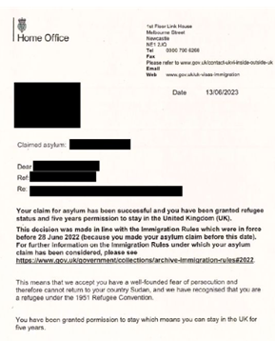

* 1. The training provider should take a copy of the immigration documents and also check on the [Employer Checking Service](https://www.gov.uk/employee-immigration-employment-status).

For more information, check the [Employers guide to right to work checks](https://assets.publishing.service.gov.uk/government/uploads/system/uploads/attachment_data/file/1071247/Employer_s_Guide_to_Right_to_Work_Checks__PDF_.pdf) or contact [employability@scottishrefugeecouncil.org.uk](mailto:employability@scottishrefugeecouncil.org.uk)