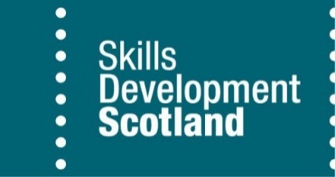
Inclusive Recruitment and Support for People with Disabilities

A guide for apprenticeship learning providers and employers

Why Inclusive Recruitment Matters

Proactive inclusive recruitment ensures that everyone has fair access to opportunities and that organisations benefit from the widest possible talent pool. Currently, more than one in five working-age people in the UK are disabled, yet many remain economically inactive. Creating accessible pathways into apprenticeships not only supports equality and social mobility but also brings real business benefits — including improved staff retention, innovation, and enhanced workplace culture.
Skills Development Scotland (SDS) is committed to helping both employers and learning providers attract, recruit, and support disabled people into the workplace. The following resources have been developed to build confidence, improve inclusive practices, and create positive outcomes for all.

Resources Overview

For Providers | For Employers (and providers)
• Mental wellbeing support for apprentices  • Supporting apprentices around suicide and self-harm  • Able Futures Employer Toolkit: Mental Health at Work | • Able Futures Employer Toolkit: Mental Health at Work  • Mental health and wellbeing support for apprentices  Looking after mental health at work
•Equality Monitoring Form Guidance  •Foundation Apprentice  •Modern Apprentice  •Graduate Apprentice | Needs Assessment Handbook  • Guide to Positive Action  • Challenge Cards (1–8)  • Challenge Cards (9-16)
•Enhanced Funding Guidance  • Appendix 4A Application Form  • 4B Change of Support Requirements | • Inclusive Recruitment Guide  • Unlock the Potential of Inclusive Recruitment recorded webinar
• Neurodiversity E-Learning Course  Raise awareness of the concept of neurodiversity and how to support neurodiverse individuals. | • Neurodiversity Handout for Line Managers  •Neurodiversity Handout for Group Sessions
Access to Work Awareness Sessions  Upcoming online CPD sessions for providers.  9th Dec 10:30-12:00 Password: SDS  16th Dec 13:30-15:00 Password: SDS | •Project SEARCH | VIAS  Employment-focused education programme for young people with learning disabilities and/or autism, offering real workplace experience.
For more information and to access these resources, visit Skills Development Scotland’s website.

