Communication toolkit to support our partners promote the upcoming **Girls do Science!** events for S1 to S6 female pupils at Skills Development Scotland Inverness Digital Studios on Friday 15 and Saturday 16 March 2024.

Please use the suggested copy and assets provided in this toolkit to promote these events to your pupils.

Thank you.

**Suggested web/newsletter/email copy:**

**Girls do Science! Events return to Inverness**

Girls do Science! free event series returns on Friday 15 and Saturday 16 March 2024 to Skills Development Scotland’s Inverness Digital Studios, 1-5 Church Street, IV1 1DY.

The two-day STEM-focused events invite S1 to S6 girls to come along to explore careers and creativity in and around STEM industries.

On Friday 15 March from 6:30 to 7:30pm, there is an informal networking event for S4 to S6 girls, where they will get to meet inspirational women working in STEM industries, ask questions, and make useful contacts. This is a fantastic opportunity to meet motivational women whose careers are within this exciting and fast-growing industry.

On Saturday 16 March, from 10am to 2:15pm, S1 to S3 girls are invited to join us for a day of female speakers working in STEM industries and gethands-on in our interactive workshops including ‘Bridging Islands with Renewable Energy’, ‘Understanding Vaccines’, ‘Project Peat’, ‘Eco Mapping’, and ‘Moss Testing’.

Sharon McIntyre, Head of CIAG Operations at Skills Development Scotland says: “These events are the perfect opportunity to empower young women through learning for scientific and technological career paths. They’ll get information and guidance directly from inspiring role models and be offered a glimpse into the reality of being a female employed in the field of science and/or technology.”

Light refreshments will be provided at both these free events. Places are limited so be sure to use the links below to book soon to avoid disappointment!

* S4 to S6 - Friday 15 March – [networking event for S4 to S6 girls](https://www.eventbrite.co.uk/e/girls-do-science-2024-networking-event-tickets-818624587177)
* S1 to S3 - Saturday 16 March – [workshops and speakers’ day for S1 to S3 girls](https://www.eventbrite.co.uk/e/girls-do-science-2024-tickets-818836180057?aff=oddtdtcreator)

Find out more about these events, and other activities at the Digital Studio at Skills Development Scotland Inverness, by getting in touch with [studioinv@sds.co.uk](mailto:studioinv@sds.co.uk)

**Promotional flyer**

[Click here to download a digital version of the event flyer.](https://www.skillsdevelopmentscotland.co.uk/media/wh0h1gov/gds-flyer-2024-final.jpg)

**Suggested social media posts and graphics - right click on the images and select ‘save as picture’:**

**S1 to S3 girls:**

* Are you an S1 to S3 girl interested in a STEM career? Come along to Girls do Science! on Sat 16 March, 10am to 2:15pm at Skills Development Scotland Inverness IV1 1DY for a day of hands-on workshops and inspirational talks. Book: <https://girlsdoscience2024.eventbrite.co.uk>

**FB image: X image:**

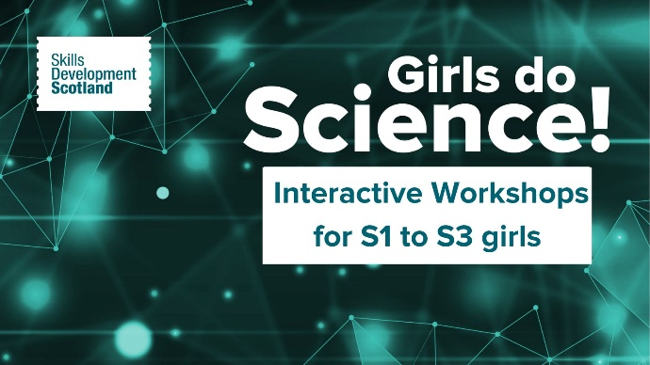

**S4 to S6 girls:**

* Are you an S4 to S6 girl and interested in a STEM career? Come to Girls do Science! on Fri 15 March, 6:30 to 7:30pm at SDS Inverness - IV1 1DY for an evening of networking with inspirational women working in STEM industries. Book: <https://gdsnetworking2024.eventbrite.co.uk>

**FB image: X image:**

**Thank you.**