
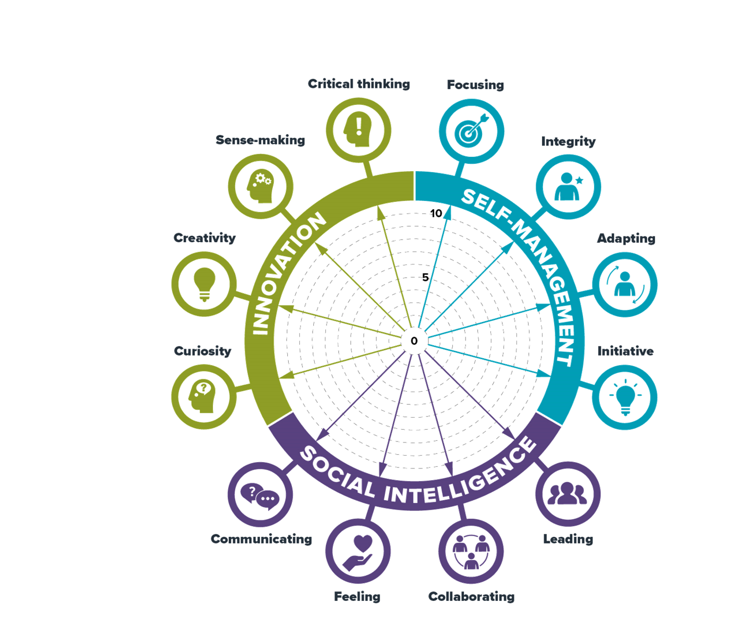
Self-evaluation wheel

How to use the wheel:
- Please read the guidance document and use the suggested questions in the guidance to support
your conversations with apprentices.
- There are separate work sheets for each of the broad headings for meta-skills
  - Innovation
  - Self-management
  - Social intelligence

Apprentices can use these worksheets to support their reflection with their development of meta-skills.
They can be adapted to include different questions, everyday language and terminology appropriate
to your apprentices. We have included examples of everyday terms in this document
to support your discussions about meta-skills in practical workplace contexts.
The wheel can be revisited over time, and completed worksheets should be retained and used
as portfolio evidence of the Apprentices meta-skills development

Step 1
- Taking each meta-skill in turn
- Plot yourself on the arrow with a dot:
  - 0 = not confident/areas to develop
  - 10 = very confident/accomplished in this area
- Use the questions on the worksheet to capture the evidence about ‘why’
you have placed yourself at each point
- Join up each of the dots once you have completed all of them

Step 2
Looking at your completed wheel, take time to reflect on the following questions:
What do I notice?
- What meta-skills stand out as areas of strength?
- What meta-skills do I need to focus on improving?
- How might these areas impact on each other?

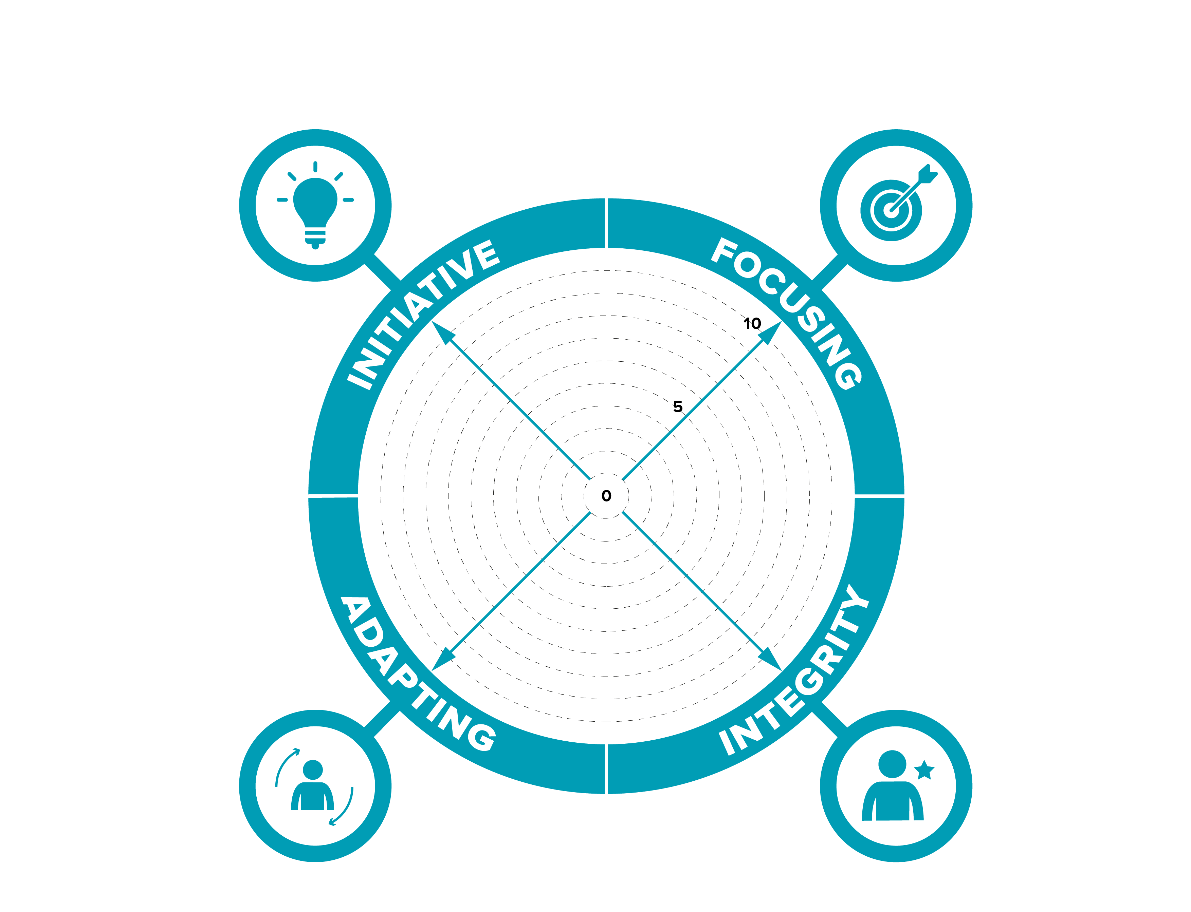

Self-evaluation wheel
How to complete this worksheet:
- taking each meta-skill in turn
- Plot yourself on the arrow with a dot: 0 = not confident/areas to develop
10 = very confident/accomplished in this area
- Under each question capture examples that evidence ‘why’ you have placed yourself at each point

How well do you think for yourself?
I think I am quite good at thinking for myself, but I am still learning. I sometimes need to make quick decisions, like checking delivery notes, finding the right stock, or deciding what to do if something is missing. I try to look at the information first and not just guess. If I am unsure, I ask my supervisor before I carry on. I think this shows I can use my own judgement, but I also know when I need support.

SELF-MANAGEMENT
Can you concentrate on what’s important?
I think I can concentrate most of the time. In logistics, there can be a lot going on at once, like deliveries coming in, stock needing checked, and paperwork needing completed. I try to focus on safety first, then the task I have been given. When I am picking orders, I check the product codes carefully so the customer gets the right items. I can get distracted sometimes, especially when it is busy, so I am working on taking my time and double-checking my work.

How well do you adjust to change?
I think I am getting better at this. In this job plans can change quickly, like when a delivery is late or an order is changed, or I am asked to help in a different area. At first, I found this a bit stressful because I like knowing what I am doing. Now I try to stay calm, listen to instructions, and ask questions if I do not understand. I think I am improving because I can move on to a new task without getting too frustrated.
How well do you stay true to yourself?
I try to be honest, turn up on time, and do my work properly even when no one is watching. If I make a mistake, I would rather say something than hide it, because mistakes in logistics can affect customers, stock, or safety. I also try to treat people with respect and not copy bad habits from others. I know I still have more confidence to build, but I want to be known as someone who is reliable and willing to learn.

Self-evaluation wheel

How to complete this worksheet:

- taking each meta-skill in turn
- Plot yourself on the arrow with a dot: 0 = not confident/areas to develop
10 = very confident/accomplished in this area
- Under each question capture examples that evidence ‘why’ you have placed yourself at each point

How well do you express yourself and
share information?
I think I am getting better at explaining things clearly. I try to pass on the right information about stock, deliveries or any problems, so the team knows what is happening

Do you understand how other people
are feeling?
Sometimes, I try to notice when people busy or look at bit stressed. I try to stay calm and be helpful and not make things harder. I’m still learning how to do this better

How well do you lead by example and
Inspire and motivate others?
I am still learning to lead,
but I try to set a good example
by turning up on time, working hard
and doing tasks properly.
I think I can try harder and get others to do the same.

How well do you work with other people?
I think I work well with others.
In logistics, we need to work as a team
to get orders picked, packed and sent out on time,
so I try to help and do my part but I could do better at this

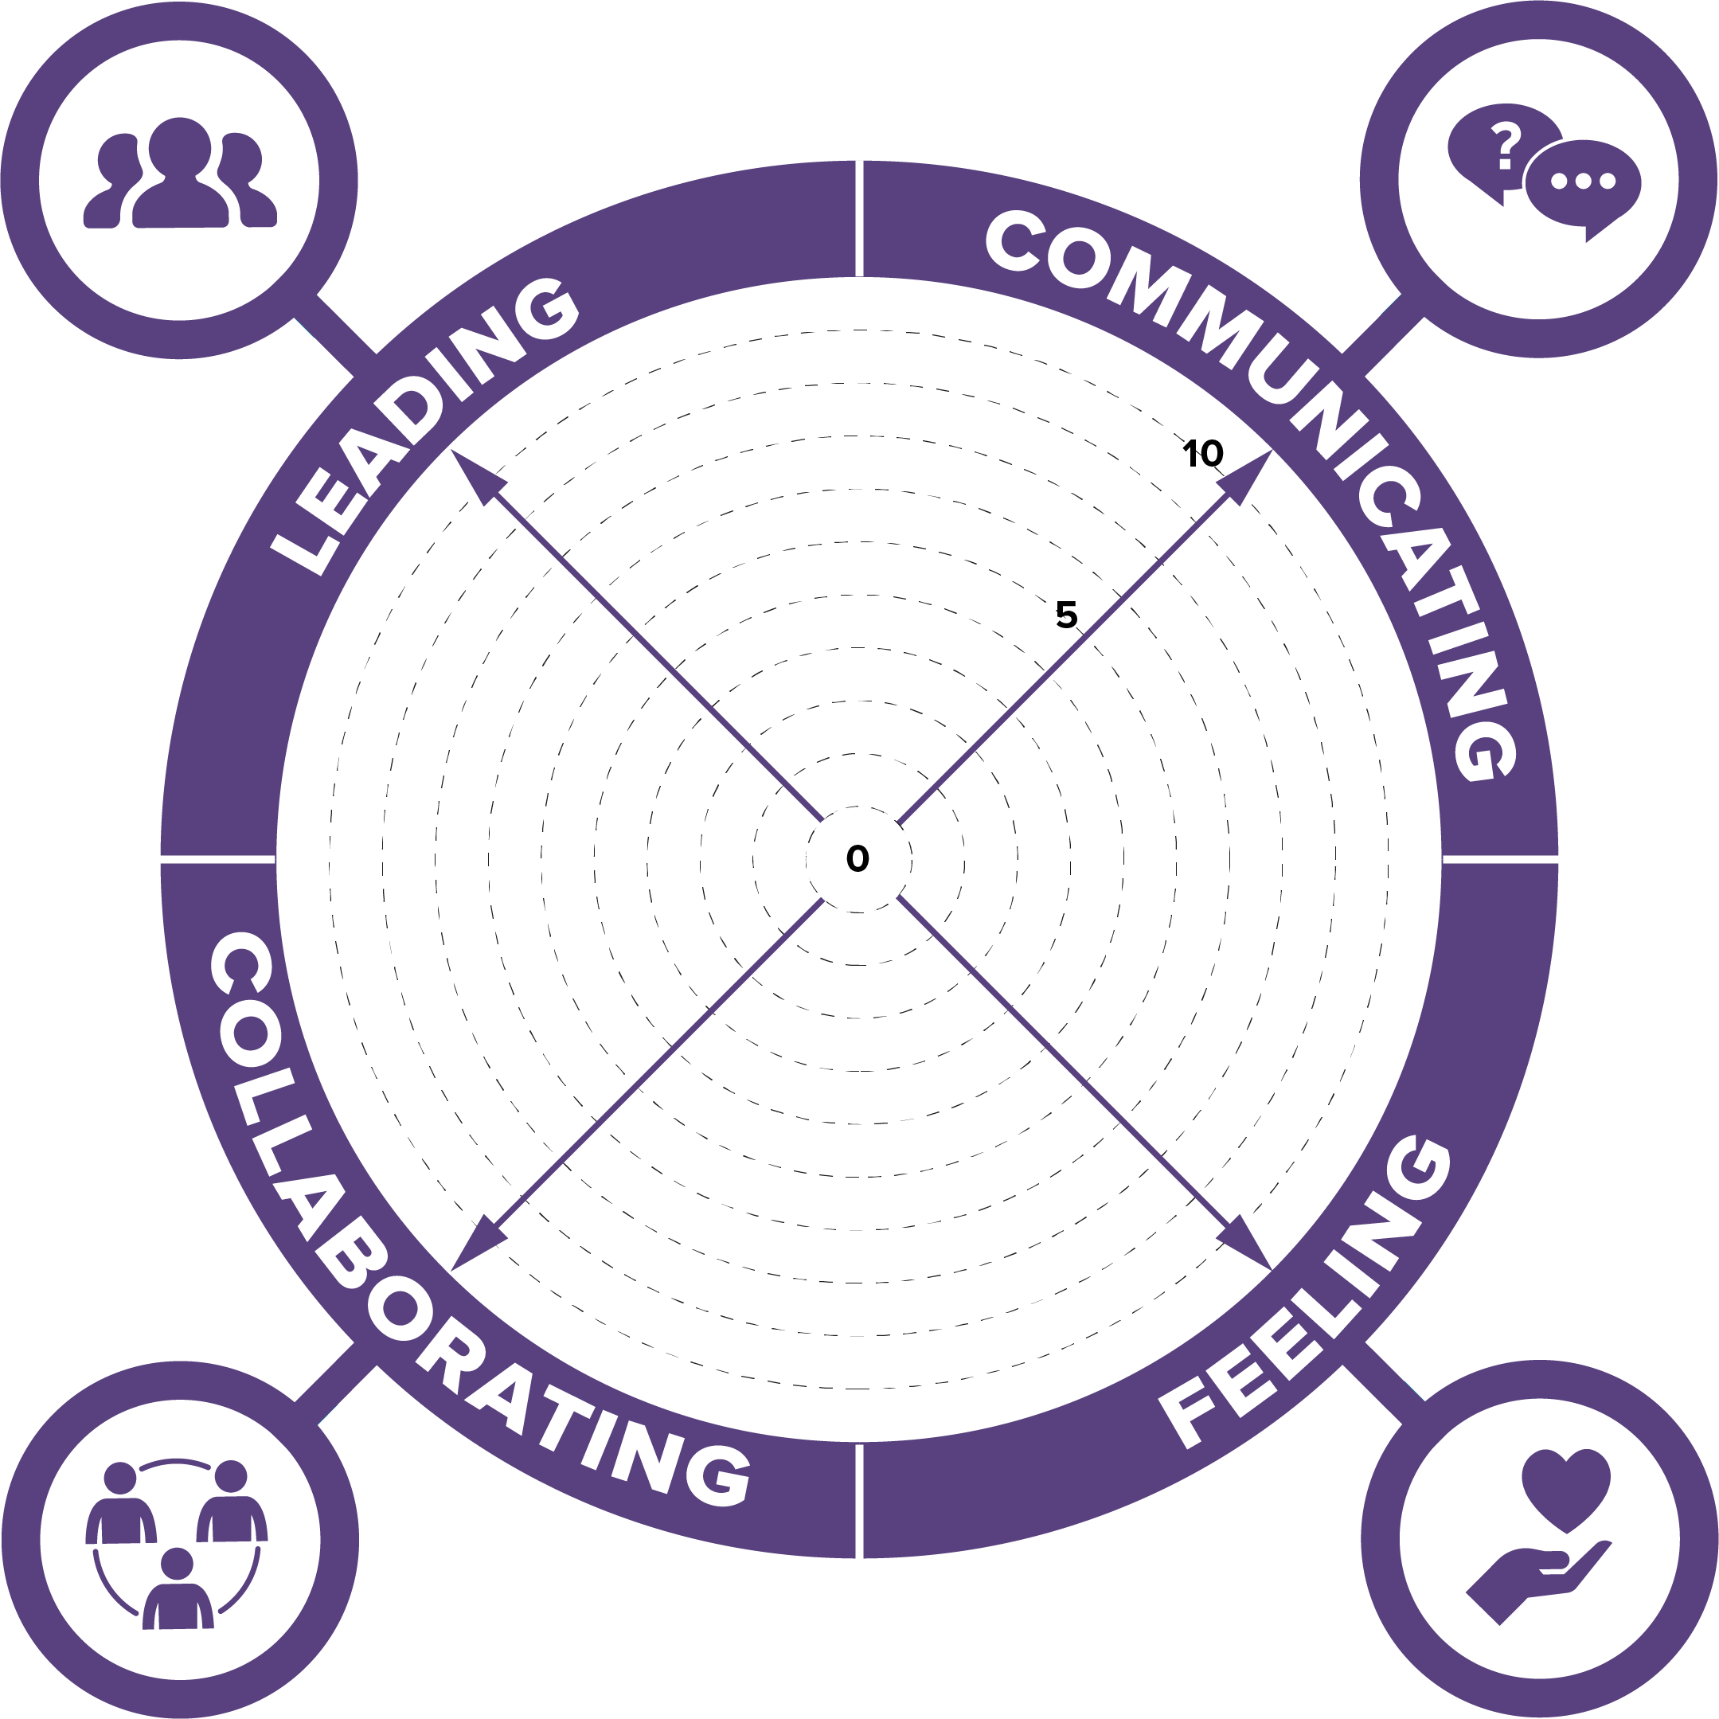
SOCIAL INTELLIGENCE

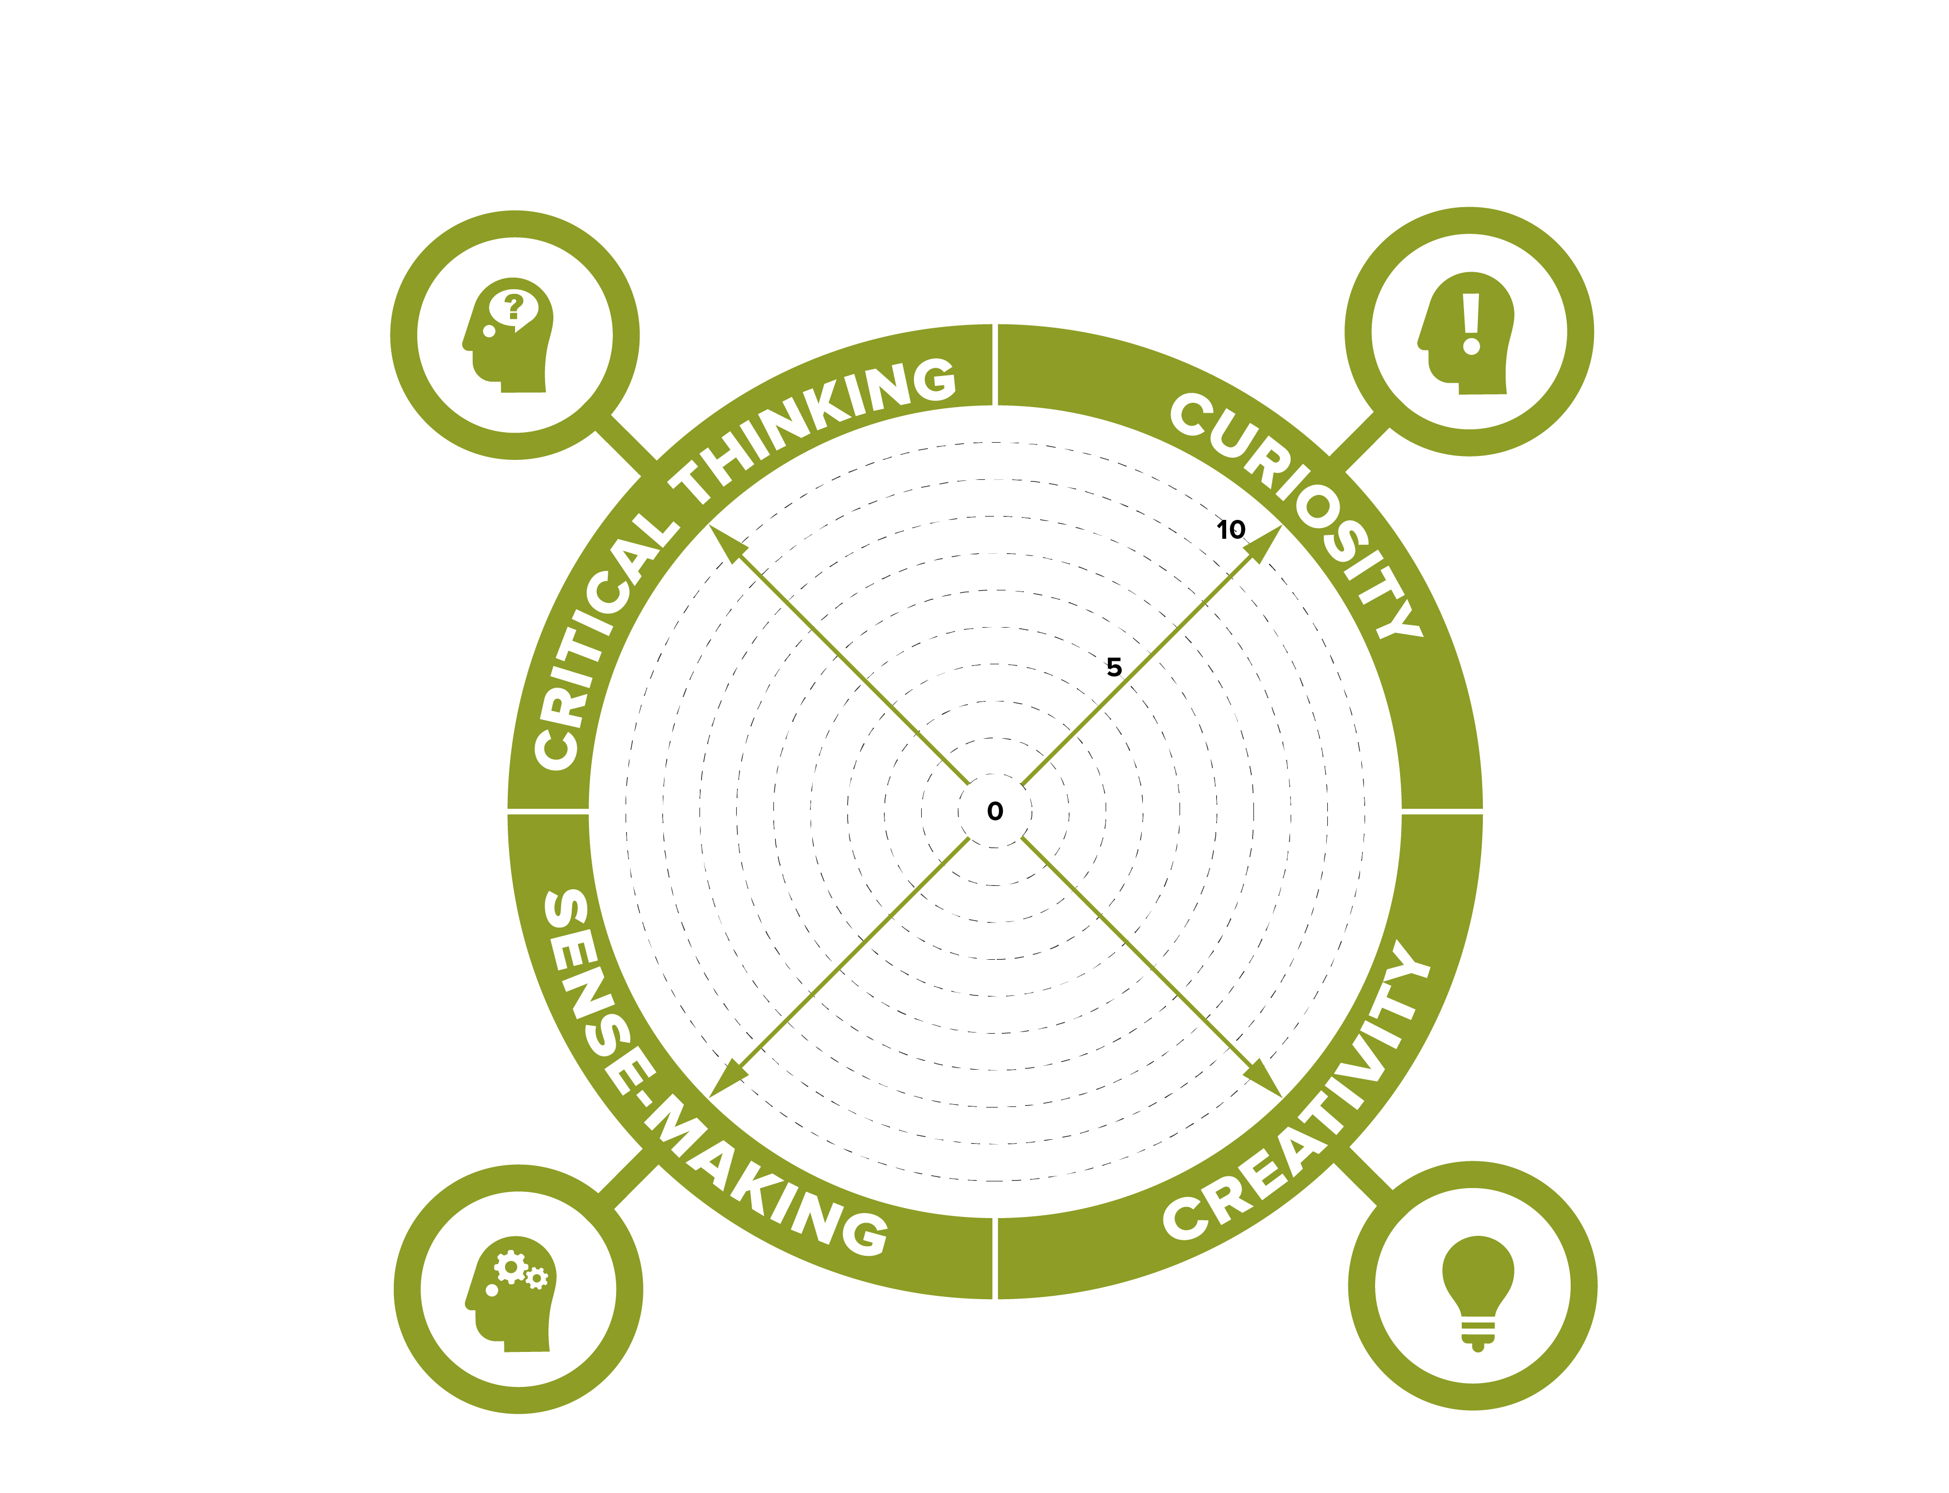
Self-evaluation wheel

,
How to complete this worksheet:
- Taking each meta-skill in turn
- Plot yourself on the arrow with a dot: 0 = not confident/areas to develop
10 = very confident/accomplished in this area
- Under each question capture examples that evidence ‘why’ you have placed yourself at each point

How do you think and evaluate information?
I check the information I have, like delivery notes, stock lists or instructions. I try to make sure it is correct before I act. If something does not look right, I ask my supervisor

How do you recognise patterns in things around you?
I notice when the same things happen again, like busy delivery times or stock being picked often. This helps me understand what might happen next and plan better.

INNOVATION
How good are you at asking the right questions?
I think I am getting better at asking questions. I ask if I do not understand a task or if something looks wrong with stock, paperwork or an order.

Can you think for yourself and think of new ways to do things?
I can think for myself more now than when I started. If there is a problem, I try to think of a sensible way to fix it before asking for help. I also try to find easier or safer ways to do tasks.

