Theme 1: Extensive Campaign

Enabling our schools and communities to better understand the scale of local opportunity | Understand workforce demands across Highland |  |  | Develop and deliver an inclusive local campaign |  |  |  | Monitor workforce flow into Highland Labour Market
Actions | H1.1  Collate job and skills requirements for Highland Council region based on growth, inward investment and replacement demand | H1.2  Utilise Employers’ group to finalise most critical in-demand jobs, careers and skills across Highland Council region | H1.3  Identify / agree information to be included in the campaign | H1.4  Design awareness raising campaign to target audiences  -pupils (primary / secondary)  -FE/ HE students  -community and underrepresented groups  -parents / carers  -unemployed /underemployed  -career changers  Etc. | H1.5  Align to local campaigns such as ‘Love Lochaber’ etc | H1.6  Deliver awareness raising CPD to career influencers (School, College, University Staff, DYW, DWP, Career Practitioners | H1.7  Deliver campaign to audiences  -pupils (primary / secondary)  -FE/ HE students  -community and underrepresented groups  -parents / carers  -unemployed /underemployed  -career changers | H1.8  Review pupil preferred routes / occupations data and pupil voice survey responses to monitor pupil aspiration alignment to workforce demands | H1.9  Engage with employers, FE / HE, Training Providers to monitor if campaign is improving supply of talent pipeline into key sectors
Partners | SDS  Employer Group, HIE, UHI, Highland Council | Employer Group, SDS, Highland Council,  UHI, HIE, | Highland Council,  SDS, HIE, UHI, DYW, | Highland Council, DYW, HIE, SDS, DWP,  Schools, Employer Group, HEP, UHI, Community Groups |  |  |  | SDS, DYW, UHI, Highland Council | SDS, Highland Council, DWP, Chamber, DYW, Employer Group, FSB, HIE, SFC
Industry Partner |  |  | ICFGF | ICFGF
Expected completion Date | Nov ‘25 | Dec ‘25 | Dec ‘25 | March ‘26 | March ’26 | June ‘26 | June ‘26 | Oct ‘26 | March ’26
1.1 Develop & deliver local promotional packages i.e. 'My Highland Future' | 

Theme 2: School & Wider Community Focus (1)

Generating the future workforce and improving access to fair work opportunities | Expand and embed ECL / FAs |  |  |  |  | Promote Apprenticeship Pathways |  |  | Monitor workforce flow into apprenticeships within Highland
Actions | H2.1  Establish inter-agency partnership to review current ECL & FA provision to identify gaps across Highland in relation to the data from Theme 1. | H2.2  Identify / develop relevant ECL / FA provision to fill gaps identified  Secure employer commitment to deliver ECL / FA opportunities | H2.3  FA / ECL offer embedded into curriculum across Highland  Address barriers such as timetabling, transport, flexible delivery etc | H2.4  Develop & deliver programme of CPD for ECL / FA delivery leads | H2.5  Design FA, MA, GA promotional campaign (incorporating fair work principles) to highlight benefits of apprenticeship pathways aligned to extensive campaign created in Theme 1 (consider use of ambassadors) |  | H2.6  Deliver the campaign to parents/carers, pupils and other key groups as well as those furthest from labour market | H2.7  Secure employer commitment to promote apprenticeships in line with preparation for key academic transition points | H2.8  Review uptake of ECL / FA in line with areas of labour market demand | H2.9  Review uptake of MA / GA from school in areas of labour market demand and numbers of young people choosing to stay in the region post school
Partners | Highland Council, SDS, DYW, UHI, HISP, HIE, SFC | Highland Council, DYW, SDS, HIE, UHI, HISP, Third Sector, SFC, Education Scotland, Employer Group | Highland Council, Education Scotland | Highland Council, UHI, DYW, SDS | SDS, Highland Council (tied to theme 1), DYW, UHI, Employer Group |  | DYW, SDS, UHI Highland Council | DYW, Employer Group, Highland Council, DWP, SDS | Highland Council, SDS, UHI, SFC, DYW | SDS, SFC, UHI, other HE institutions
Industry Partner |  | ICFGF |  |  |  |  | ICFGF | ICFGF
Expected Completion Date | Dec ‘25 | March ‘26 | June ’26 | May’26 | Dec ‘25 |  | March ’26 | March ‘26 | Sept’25 – Aug’26 | Sept’25 – Aug-26
2.1 Expand & embed Experiential Career Learning (ECL)
2.2 Promote work-based learning pathways and their benefits
2.3 Rapidly expand FA offer in schools

Theme 2: School and Wider Community Focus (2)

Generating the future workforce and improving access to fair work opportunities | Expand work experience opportunities |  |  | Targeted response to address urgent industry skills needs |  |  | Improve process for WBL applicants |  | Initiatives to improve access to fair work in areas of labour market opportunity
Actions | H2.10  Identify critical barriers and solutions to expanding work experience offer such as timetabling, budgets for risk assessments etc | H2.11  Develop improved work experience offer linked to Theme 1 data and embed within overall ECL offer (e.g. ‘Apprentice for a Day’) | H2.12  Promote expanded offer in areas of labour market opportunity | H2.13  Identify appropriate partners and create local workforce response teams | H2.14  Engage with industry to identify and support with urgent workforce requirements | H2.15  Implement appropriate response approaches to attract workforce / meet industry needs e.g. pop-up shops, careers events, webinars etc | H2.16  Explore portal/platform options to improve application process / experience for WBL candidates including those who are unsuccessful (e.g. PATS model) | H2.17  Promote WBL application process and implement within industry including through supply chains | H2.18  Review existing pre-employment schemes and programmes of support (CECA etc) with guaranteed interviews and identify gaps aligned to areas of labour market need identified in Theme 1. | H2.19  Expand schemes, focusing on all individuals including those removed from the labour market or within marginalised groups | H2.20  Review schemes impact on addressing inequalities, reducing underemployment and unemployment
Partners | Highland Council, DYW, SDS, DWP |  |  | SDS, HIE, DYW, Highland Council (HEP), DWP, UHI, Third Sector, Employer Group |  |  | SDS, Employer Group, NMIS, CITB, UHI, SDS, DWP |  | Highland Council (HEP), DWP, Employer Group
Industry Partners |  |  |  | ICFGF
Expected Completion Date | Dec ‘25 | Dec’25 | Apr’26 | Dec ‘25 | Dec ’25 | Apr’26 | Dec ’25 | Apr’26 | Dec’25 | Apr’26 | Quarterly
2.4 Improve work experience offer & identify challenges
2.5 Create local ‘Workforce Response Teams’ (PACE in reverse
2.8 Establish a clearing system for unsuccessful WBL applicants
2.9 Expand pre-employment schemes that include guaranteed interviews
2.11 Make access to future fair work economic opportunities more equitable

Theme 3: Apprenticeship Expansion

Develop new approaches to deliver an expanded offer | Frameworks, delivery models & numbers |  |  | Employer Uptake |  | Funding | Articulation Routes
Actions | H3.1  Identify where MA/GA provision needs to be dialled up or down  Leading to the identification of in-demand frameworks and no. apprentices required to meet demand (e.g. GAs in Engineering) | H3.2  Establish process for use of co-investment model with employers to drive increased delivery | H3.3  Develop new delivery models eg. host employer, tech enabled’ AI, pre-apprenticeships, UHI apprenticeship +, blended approach, increased peer to peer support | H3.4  Engage with and promote MA/GA benefits to employers through best practice support | H3.5  Apprentice targets applied to procurement and CWB plans (Social Value Charter) and confirm employer input into shared apprenticeship or innovative models (e.g. Morrison ‘Build Your Future’). | H3.6  Ensure appropriate level of SFC credits is in place to allow HEIs to deliver in areas linked to labour market demand, and contract flexibility for training providers to align MA provision to employer needs (equitably across Highland region).  Identify and implement solutions to overcome barriers to delivery i.e. SFC funding model for rural areas | H3.7  Map out articulation of vocational learning to FA to MA / GA and embed in Theme1/ 2 promotional activity
Partners | SDS, Employer Group, SFC, UHI, RGU, HW, DYW | SDS, SFC, Employer Group, UHI, training providers, DYW | SDS, UHI, training providers, SFC, DYW | SDS, Highland Council, UHI, SFC, training providers, DWP, DYW | Highland Council, Employers | SFC, UHI, RGU, HW, SDS, training providers | SDS, Highland Council, UHI, RGU, HW, SFC,
Industry Partner |  | ICFGF |  |  |  |  | ICFGF
Expected Completion Date | March ’26 | March ‘26 | Apr-26 | Apr’26 | April ‘26 | Dec ’25 | Jan ‘26
3.1 Increase MA starts in line with evidenced need
3.3 Ensure institutions have infrastructure and capacity to deliver required training in priority areas.
3.5 Expand GA offer
3.2 Implement more flexible apprenticeship delivery models
3.6 Influence local CWB Action Plans to consider WBL in procurement

Theme 4: Upskilling / Reskilling

Short, sharp opportunities for those seeking a new role | Increased provision linked to areas of  labour market need |  |  |  |  |  |  | Improved Access |  | Funding
Actions | H4.1  Map out existing industry focused provision and identify gaps aligned to labour market need data from Theme 1. | H4.2  Map out employers’ upskilling / reskilling requirements | H4.3  Develop new/enhanced offer linked to labour market supply (over 50s, armed services early retirement etc) and demand, scope skills passport options (including entrepreneur training options) | H4.4  Identify solutions to overcome barriers to delivery (inc. employer funding contributions; skills acadamies, Charter) | H4.5  Establish ‘Train the trainer’ needs and implement CPD as required | H4.6  Create more employer funded internship places to get more people into industry | H4.7  Create unified prospectus & application process. Enhancing and promoting local provision aligned to ‘pillars of expertise’ to priority market segments | H4.8  Implement Workforce North upskilling / reskilling co-ordinator role to create ‘one front door’ delivery mechanism for strategic industry engagement | H4.9  Utilise co-ordinator role to provide support for candidate applications from marginalised groups (e.g. ex-offenders) | H4.10  Identify funding requirements for up and re skilling (e.g. FWDF request, ICFGF Skills & Innovation Fund) | H4.11  Create new funding models (low interest loans etc), and communicate finance options to potential applicants via co-ordinators
Partners | UHI, HIE, training providers, DWP | SDS, Employer Group, HIE, DWP, Third Sector | UHI, SDS, Training Providers, DWP | UHI, training providers, employers, DWP | UHI, training providers, employers | Employer Group, DYW, Highland Council (as employer), UHI, DWP | UHI, SDS SFC, DWP, NMIS | UHI, Highland Council (HEP), SDS, DWP, UHI, training providers |  | SFC, SDS, SG, UHI, Training Providers, consider engaging (not for profit) financial adviser, DWP
Industry Partner |  | ICFGF |  |  |  | ICFGF |  |  |  | ICFGF
Expected Completion Date | March ‘26 | Dec’25 | March’26 | Dec’25 | March ’26 | March ’26 | Dec ’25 | March’26 | March’26 | March ’26 | March ’26
4.5 Creation of upskilling/reskilling co-ordinators
4.1 Design & deliver short, sharp training offers for those changing roles & returning to the labour market.
4.3 Consider options to increase the number of internships
4.4 Creation of job access fund / low interest loan scheme

Theme 5: Talent Attraction and Retention

Encouraging people to return home & attract new people to the area | Developing a marketing strategy to attract talent |  |  | Supporting new talent into the area |  | Attracting and retaining FE / HE talent
Actions | H5.1  Develop a regional marketing strategy outlining both regional & local opportunities to encourage people to work in the region | H5.2  Engage with Highland employers to contribute to marketing strategy outlining the scale of labour market opportunities and place-based benefits to relocating to the Highland region. | H5.3  Incorporate key messages around school provision, housing, local support services etc to attract wider family members to move to the area | H5.4  Implement consistent on boarding approach (potentially web based) for the Highland region to support individuals moving to the area with housing etc | H5.5  Use mixture of digital (AI) and face to face events to promote opportunities internationally or to the remaining home nations of the UK. | H5.6  Expand UHI support packages to attract new FE / HE students (industry bursaries etc). | H5.7  Attract Highland domiciled students back for the summer through summer placements via collaboration between UHI and other HEIs | H5.8  Promote and expand industry/HE Knowledge Transfer Partnerships | H5.9  Promote specialist MSc and PhD programmes | H5.10  Promote, expand, reinstate successful ‘Graduate into Industry’ schemes and Graduate Placement Programmes (HIE)
Partners | HIE, Highland Council, CPP, Visit Scotland, Employer Group, UHI, DWP, DYW | Employer Group, HIE, Highland Council, Visit Scotland, UHI, SDS, DWP, DYW | Highland Council, HIE CPP, Visit Scotland, Employer Group, UHI, DWP, DYW | Highland Council (Place), HIE, UHI, SDS, Employer Group | HIE, Highland Council, Employer Group, SDS, UHI, DWP, HIE | UHI, HEIs, SFC Employer Group | UHI, HEIs | UHI, HEIs, Employer Group | UHI, HEIs | UHI, HEIs, HIE Employer Group, DYW
Industry Partner | ICFGF | ICFGF | ICFGF |  |  | ICFGF
Expected Completion Date | Jan’26 | Jan ‘26 | Jan’26 | March ‘26 | March ’26 | March’26 | March ‘26 | Apr ‘26 | Apr’26 | Aug’26
5.1 Attract working age people through a UK and international campaign
5.2 Attract & retain HE candidates to the region

Appendix 1: Highlands & Islands Regional Workforce North Implementation Plan
The Operational Road Map for the Highland Region has been developed from the overarching regional implementation plan for the Highlands and Islands created from the initial Workforce North Summit in April 2025. A summary of which is below.
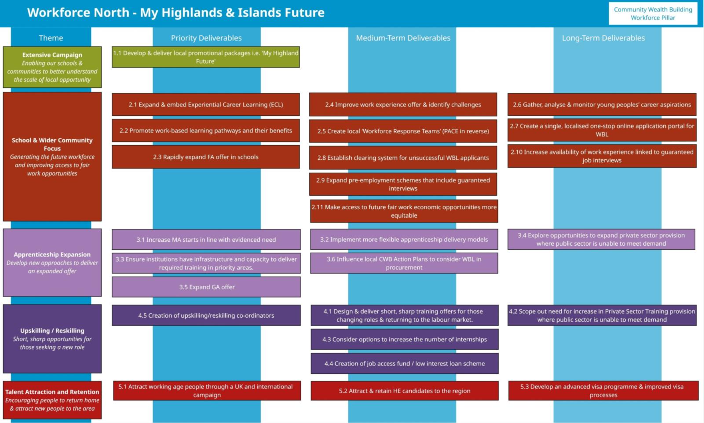

Appendix 2: Terms of Reference for the Highland Workforce North Operational Delivery Plan

Terms of Reference - Highland Workforce North Operational Delivery Plan
1. Purpose
To oversee, coordinate, and drive the delivery of the Highland Workforce North Operational Roadmap, ensuring all themes and actions are implemented effectively to meet regional workforce needs, support economic growth, and improve opportunities for people and employers across the Highland region.

2. Objectives
Deliver the five key themes of the Operational Roadmap:
1. Extensive Campaign
2. School & Wider Community Focus
3. Apprenticeship Expansion
4. Upskilling / Reskilling
5. Talent Attraction and Retention
Monitor progress against agreed actions, milestones, and outcomes.
Foster collaboration between all partners and stakeholders.
Identify and address risks, barriers, and resource needs.
Report progress and make recommendations to the SDS / Highland Council joint programme management team.

3. Membership
Project Lead: SDS
Project Management: SDS, Highland Council
Core Members: Representatives from SDS, Highland Council, HIE, UHI, DYW, SFC, DWP, HEP, Employer Group, ICFGF, Industry Partners, Third Sector, Education Scotland, Training Providers, Community Groups, and other relevant agencies.
Additional Members: As required for specific themes or actions.

4. Roles & Responsibilities
Project lead: Alignment to WFN High Level Plan, HIREP Skills & Labour subgroup governance process & reporting to COHI
Project Management: Liaise with project members to monitor and report on delivery against actions
Members: Lead/participate and deliver against assigned actions, share data and insights, escalate issues & barriers to delivery.
Theme Leads: Coordinate delivery, monitor progress, and report progress to PMO.

5. Governance & Reporting
Project lead will report to HIREP Labour & Skills subgroup.
SDS will provide written progress report to COHI on November 25 and at future COHI meetings as requested by DFM.

7. Resources
Members will contribute staff time and expertise as part of their organisational commitment.
Additional financial or co-investment opportunities may be identified and agreed as required for delivery.

8. Review
The Terms of Reference will be reviewed annually or as required to ensure they remain fit for purpose and aligned with regional priorities.

