Meta-skills delivery procedure for Modern Apprenticeship providers

March 2022

Contents

Background 3
Meta-skills delivery process 3
General guidance 4
Information about the SDS meta-skill tools 5
1. Meta-skills profiling tool 6
2. Meta-skills self-assessment tool 7
3. Record of meta-skills development tool and review meeting 8
4. Summary of meta-skills development tool 9
Additional guidance 10
Appendices 11
Appendix 1: Work Situations – Meta-skills matrix 11
Appendix 2: Flowchart for meta-skills development 12
Appendix 3: Using the SDS meta-skills profiling tool 13
Appendix 4: Using the SDS meta-skills self-assessment tool 15
Appendix 5: Meta-skills Professional Discussion Prompts 17
Appendix 6: Meta-skills reflection guidance 18
Appendix 7: Record of Meta-skills Development (completed) 23
Appendix 8: Meta-skills Development Summary (completed) 25
Appendix 9: Blank Templates 27

Background
The paper Skills 4.0 - A skills model to drive Scotland’s future sets out the context in which work, and the nature of the workforce, is expected to change in the near future. This ‘fourth industrial revolution’ is characterised by exponential change, to cope with which, individuals and businesses will need to develop meta-skills that support learning, improvement of existing skills and development of new ones. For example, learning a language is a skill, while the ability to learn languages is a meta-skill which makes it easier to learn several.

Meta-skills are defined as timeless, higher order skills that create adaptive learners and promote success in whatever context the future brings. A meta-skill is a high order skill which is a catalyst for learning and building new skills faster.

Meta-skills cannot be demonstrated outside of their context, therefore are most effectively learned and developed in the workplace. This makes work-based learning a key element in delivering meta-skills, meaning that their development must be embedded in learning programmes. Skills Development Scotland has tested the implementation of meta-skills delivery in Foundation and Graduate Apprenticeship programmes. Going forward, all Modern Apprenticeship frameworks will be developed under the new Scottish Apprenticeship Advisory Board (SAAB) principles and will be underpinned by meta-skills. Meta-skills have already been included in the Technical Apprenticeship in Project Management and the Providing Financial Services Modern Apprenticeship, while work is currently ongoing to introduce them into other Modern Apprenticeship frameworks under development. As new frameworks are implemented, providers will be expected to play a key role in supporting their apprentices with the development of meta-skills in the future.

This document is intended as general guidance for the delivery and recording of the development of meta-skills within a Modern Apprenticeship framework.

Where meta-skill assessment is identified as part of the learning outcomes of a qualification underpinning an apprenticeship, it is very important that the provider meets the criteria of assessment, and the assessment strategy identified in that qualification as required by the Awarding Body.

Meta-skills delivery process
There is a series of steps involved in the process of moving the apprentice from a position of little knowledge or understanding of meta-skills, through building awareness, to confidence in using the meta-skills required in their job role and work setting. A learner’s journey in their meta-skill development from awareness to confidence is very unlikely to be linear and will vary for different skills. The diagram below shows how a coach/tutor/assessor can support the learner to make that journey explicit for the various skills as they progress through their apprenticeship.

SDS has developed this guidance on the recording of meta-skills development, and a library of tools that providers may choose to use to support that delivery. It is, however, important to realise that meta-skill delivery and assessment is a learning curve for everyone and this guidance is likely to be reviewed and updated as we learn more about effective practice in their delivery.

General guidance
Central to the process of delivering meta-skills are the discussions between provider, apprentice and employer about identifying the key meta-skills the apprentice requires to develop in their job role. Providers are expected to facilitate meta-skill development of their apprentices using a proportionate coaching approach to enable development of their reflective practice skills. By the end of their apprenticeship, the apprentice should be able to describe their meta-skills development journey using reflective practice skills commensurate with the SCQF level of the apprenticeship framework. The coaching approach must be differentiated/adapted to support apprentices who face barriers to engaging effectively with reflective practice processes.

Meta-skills should be developed on an ongoing basis during the course of an apprenticeship. The Apprenticeship Qualification Design Specification for each apprenticeship will show how these meta-skills are aligned with the Occupational Profile of the apprenticeship. The mentor, line manager and/or learning provider should familiarise themselves with this mapping to help them identify work situations where there will be opportunities for meta-skills to be developed. An example of this alignment with Occupational Profiles can be found in Appendix 1 (Technical Apprenticeship in Project management)

The employer should, wherever possible, be involved at key points to identify opportunities to develop meta-skills in their apprentice’s role. The apprentice should be able to articulate meta-skills, using their own language and as they relate to their own work role/place which are likely to be aligned to those set out in the specific industry framework. As noted above, assessors should therefore familiarise themselves with the occupational profile for the framework their apprentice is working on to facilitate their coaching approach.

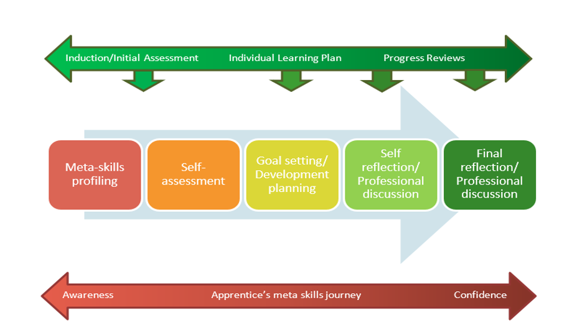
The diagram below sets out the high-level sequence of steps the apprentice may take to reflect upon their meta-skills as they develop their work-based competencies. SDS have developed some proposed tools and approaches to facilitate these steps which are set out in more detail in the next section of this guidance and a more detailed flow chart is included as Appendix 2

Scene setting or awareness raising can take place at induction, but it may be that the profiling exercise takes place later, for example at the first Apprentice Progress Review (APR) meeting. Discussion around the meta-skills and what they look like will provide evidence for the completion process at the end.

Following initial self-evaluation, the development of meta-skills should be recorded using a reflective professional discussion approach. This should involve the mentor/line manager and/or the provider and should take the form of coaching interventions guiding and supporting the apprentice in defining and articulating the relevant meta-skills and identifying their current level of awareness and confidence in those meta-skills. The discussions should involve the assessor in circumstances where the apprentice is being asked to assess/evaluate their own level of performance or measure progress achieved.

Regular reflection on the development of meta-skills through professional dialogue is an essential component of the apprenticeship and may be recorded as a reflective professional discussion.

Meta-skills can only be developed through the context of the work situations that the apprentice finds themselves in. It is important that the employer is involved in identifying opportunities early in the process to ensure it is relevant and achievable. The reflections of their development must be presented by the apprentice in their own words, and must include robust, real-life examples of situations where the apprentice has demonstrated meta-skills.

Providers can decide how to integrate delivery into their normal processes for planning, delivering and monitoring the progress of apprentices. For example, Apprentice Progress Review (APR) meetings may provide appropriate opportunities to review progress of meta-skills development and undertake recording of evidence. Providers may have paperwork already in use that can be adapted to record meta-skills progress.

Information about the SDS meta-skill tools
A range of tools to support the recording of the development of meta-skills has been developed by SDS. Use of these tools is not mandatory, and Providers may have their own specific tools or may be able to incorporate the recording of evidence into paperwork they already use. Guidance on how the provider might use the various tools provided by SDS is included below.

- Meta-skills profiling tool (Appendix 3). To be used at induction or early in the apprenticeship to develop an initial awareness of meta-skills.
- Meta-skills self-assessment tool (Appendix 4). Completed early in the apprenticeship to record the degree to which the apprentice is aware of each of the relevant meta-skills, what they look like in practice and how they can help the apprentice carry out their job role. The apprentice can identify the strengths and areas for development they would like to focus on during their next development cycle. They may wish to repeat this at certain points through their journey.
- Record of Meta-skills Development (Appendix 7) Completed, using the prompts provided in Appendix 5, by the apprentice prior to a meta-skills development review this, together with their completed self-evaluation. This is one approach to record the reflective professional discussion between the assessor and the apprentice in relation to the development of their meta-skills.
- Summary of Meta-skills Development (Appendix 8). This is one approach to capture the overall level of reflection on their meta-skills development shown by the apprentice and gives examples from the work situation of where meta-skills have been developed.

Meta-skills profiling tool

Purpose
- To develop an initial awareness of the 12 meta-skills – as part of an initial induction or onboarding process for apprentices. Both in terms of WHAT they are and HOW they might be used or developed at work.
- To develop, with support from an assessor and/or employer, a description of each skill that can be used as a reference point throughout the programme.
- To explore, with input from the assessor and/or employer, what the 12 meta-skills will look like in the context of the particular job role and workplace.
- To contribute to a portfolio of reflective practice evidence that will support conversations throughout the programme to reflect on progress, and how meta-skills were developed and used in the workplace.

The aspiration in this first exercise is to develop an initial understanding of what using meta-skills looks like in the context of the apprentice’s job role, along with language that the apprentice can use to describe them. This will require discussion with the employer and reference to the alignment of the Occupational profile with meta-skills for the framework to help identify which meta-skills are most relevant to the individual apprentice’s work context.

The exercise should be documented (Appendix 3) and include the apprentice’s descriptions of the 12 meta-skills, as well as examples of when they use (or might use) each meta-skill in their job role. This may be logged as part of the qualification evidence portfolio. The tool itself contains some additional guidance and prompts.

This exercise provides assessors with an early opportunity to gauge additional support required by individuals, to enable them to describe and understand the relevant meta-skills in the context of their job role, and the impact that any protected characteristics may have on their ability to develop their own meta-skills.

When to use
If an apprentice has been in a job for some time, profiling could be done immediately at the start of their training/at induction. If not, it may be more appropriate to wait until they have familiarised themselves with their work role, perhaps 1 month or so into starting, such as when they are setting out their individual learning plan. Apprentices must be aware of their work role and the qualifications underpinning their apprenticeship in order to consider example situations where the meta-skills may be required.

Guidance on delivery
Assessors are encouraged to focus the apprentice on the language and description of the relevant meta-skills, rather than in the details around the concept of meta-skills. The focus is on the apprentice establishing a robust understanding of the skills relevant to their job role and what those meta-skills will look like in their workplace.

Apprentices should be encouraged to develop a description of each meta-skill based on an understanding of their job role and work setting. Assessors should support and encourage apprentices to do this and should reinforce the notion that meta-skill development is a very personal, individualised process.

It is critical that the assessor does not ‘feed’ responses to the apprentice but encourages them to use research and/or discussion with peers/colleagues/their employer to help them arrive at an understanding and description of each skill in the context of their job role and workplace.

Employer involvement in the discussion is essential to ensure the employer’s understanding of the concept of meta-skills and to allow the employer to contribute to what each meta-skill might look like in their local work context.

The recorded output of the initial profiling exercise can also be used to support and contribute to reflective practice where apprentices are required to reflect on their initial perceptions/descriptions/example situations and comment on how this compares or contrasts with their experiences over the course of their apprenticeship.

Following on from the initial profiling, and after a period of time to allow the apprentice to gather evidence from the workplace of opportunities to develop meta-skills, a meta-skills review meeting may be arranged. This meta-skills development review meeting can be part of a scheduled Apprentice Progress Review (APR) meeting.

Meta-skills self-assessment tool

Purpose
- To track progress by undertaking self-assessment at regular intervals throughout the apprenticeship and comparing/contrasting responses to track growth and development.
- To identify areas of strength and areas for development that can be carried forward to support the creation of personal development actions for meta-skills as part of the apprentice’s individual learning plan.
- To contribute to a portfolio of reflective practice evidence that will support conversations throughout the programme to reflect on progress, and how meta-skills were developed and used in the workplace.

Self-evaluation supports the apprentice to gauge their levels of awareness and confidence in the meta-skills most relevant to them. This will allow the apprentice to identify their areas of strength and areas for development and take ownership of their personal growth and development.

Employer involvement in the exercise could include some reflection/suggestions on how different meta-skills will have an impact in the apprentice’s job role and which meta-skills are most relevant to the work context. This allows the apprentice to focus on the development of those meta-skills most likely to help them progress in their apprenticeship and career.

When to use
It may be appropriate to utilise the self-assessment tool after profiling and then ask the apprentice to repeat the exercise as part of their preparation for the reflective discussions with their assessor later in the process.

The self-assessments should be documented and should include: the date;, the apprentice’s levels of awareness and confidence in applying the relevant meta-skills in their job role; and their identified strengths and development areas. This should be logged as part of the qualification evidence portfolio.

Record of meta-skills development tool and review meeting

The development of the apprentice’s meta-skills should be explicitly identified and recorded through a structured discussion with their mentor, line manager and/or learning provider and should be based on the reflection of practice in the work situation.
It is important that the apprentice understands fully the purpose and requirements of the Meta- skills development review before beginning the process. This includes awareness of:
- meta-skills and what they mean in the context of their job role;
- the most recent self-evaluation of their meta-skills and the skills identified to be developed;
- opportunities in the work situation to develop meta-skills; and
- identification of practical examples of their use of meta-skills in their work situation.

When to use
The frequency of these Meta-skills Development Review meetings will depend on the length and nature of the apprenticeship and must comply with awarding body assessment strategy requirements. The appropriate time for these reviews, as noted previously, may be when apprentice progress reviews (APR) take place.

Prior to the Meta-skills Development Review meeting the apprentice should, using the prompts given in Appendix 5, complete the Record of Meta-skills Development (Appendix 7). This, together with their completed self-evaluation, will form the basis of the reflective professional discussion between the assessor and the apprentice in relation to the development of their meta-skills and allows the apprentice to:
- reflect on their work situation;
- identify practical examples of their use of meta-skills during their experience; and
- provide an appropriate level of detail to support the practical examples they identify.

The mentor, line manager and/or learning provider should ensure that where the meta-skills development review is carried out in conjunction with the progress review meeting that it is also carried out in line with the respective assessment strategy.
The template is designed to help the apprentice describe one or more work situation where there have been opportunities to development meta-skills in detail in a way that is structured.

During the Meta-skills Development Review meeting, and using the completed Record of Meta-skills Discussion document, the apprentice should be encouraged to think about different workplace situations where there have been opportunities to acquire or develop meta-skills using the prompts given. They should use the skills developed in work situations to articulate and describe the meta-skills they have developed. During this discussion, the prompts can also be used by the assessor to encourage the apprentice to reflect more deeply on their activity. Not all prompts will be appropriate for each apprentice.

The same template can be used multiple times, together with further self-evaluations, to help the apprentice explore their meta-skills development evidence in increasing depth.

Some apprentices may prefer to submit a final written version of their evidence after the Meta-skills Development Review meeting and many apprentices may prefer to complete the task orally. Discussion-based meta-skills reviews may be recorded (audio and/or video) to support quality assurance processes and to add to the evidence portfolio for the development of meta-skills.
Guidance on use
This reflective professional discussion follows on from the profiling exercise and makes use of the language/meta-skills descriptions developed previously. The exercise allows apprentices to consider each chosen meta-skill from 2 perspectives:

- How aware are they of how/where the skill is used in their job role and how/where it can help them progress in their apprenticeship and career?
- What level of confidence and opportunity do they currently have to make use of that meta-skill in their job role?

In respect of point 1, apprentices should be encouraged to speak to their employer/mentor/ assessor for input around how and where a skill may be useful to the apprentice in their job role.

The exercise gives the apprentice the chance to select the strengths and areas for development they would like to focus on during their next development cycle, and may be discussed as part of as a coaching conversation with an assessor, for example during progress review meetings.

As the apprentice gains more experience in their job role, their awareness of the situations in which they can use meta-skills should increase. Similarly, they should develop increased confidence in using the relevant meta-skills. Therefore, the personal development actions for meta-skills in the apprentice’s individual learning plan should be adjusted and updated periodically.

Summary of meta-skills development tool

Towards the end of the apprenticeship and at the final Meta-skills Development Review meeting the assessor should complete a summary of the meta-skills development and reflective practice shown by the apprentice. A completed example of the final summary of meta-skills development is shown in Appendix 7.
This should indicate:
- The overall SCQF level of the self-reflection shown by the apprentice in relation to the development of meta-skills (the level and a brief level description is available in drop-down menus on the document). A full description of the level of reflection expected at each SCQF level can be found in Meta-skills Reflection Guidance (Appendix 6).
- Examples from the work situation to support meta-skills development
- A summary of each meta-skill and a list of which meta-skills have been developed (available in drop-down menus on the document)

Additional guidance
Some apprentices may require additional support to understand and engage with meta-skills. Personal experiences and culture could impact on how apprentices engage with and/or value certain skills. Others may struggle with the concept and language used to describe meta-skills.

Assessors should remain open and respectful of the apprentice’s ideas and beliefs, while using dialogue and coaching to ensure understanding and support them through the process. You may also find it useful to use role play, or visual prompts, to support those struggling with the language.

Appendices

Appendix 1: Work Situations – Meta-skills matrix

The matrix below indicates where there are links between each of the meta-skills and the work situations which make up the occupation profile (alignment is indicated by the shaded areas).

Work Situation  Meta-skills | Supporting procurement | Supporting the management of contracts | Contributing to the management of risks | Contributing to stakeholder management | Organising and facilitating  meetings | Planning and scheduling  projects | Supporting project governance and reporting | Contributing to quality  management processes | Estimating projects and  developing budgets | Understanding the organisation and the environment it operates in | Developing personal professionalism | Supporting the business case function | Monitoring and controlling  projects | Leading and managing teams
Meta-skills
Focussing
Integrity
Adapting
Initiative
Feeling
Communicating
Collaborating
Leading
Curiosity
Creativity
Sense-making
Critical thinking

Appendix 2: Flowchart for meta-skills development

Based on a minimum of 3 review meetings during the apprenticeship. Note: more review meetings may be required to comply with awarding body assessment strategy requirements

STAGE 1 INDUCTION
Apprentice complete initial self-assessment and set goals

STAGE 2 ON THE JOB
Apprentice collects evidence from the workplace to example where meta-skills have been developed.

Prior to 1st scheduled review Apprentice drafts the Record of Meta-skills Development

1st scheduled review – apprentice meets with assessor for professional discussion, reflecting on meta-skills developed. Record of Meta-skills Development is updated if required

Apprentice continues to collect evidence from the workplace to example where meta-skills have been developed and updates self-reflection tool.

2nd scheduled review – apprentice meets with assessor for professional discussion, reflecting on meta-skills developed. Record of Meta-skills Development is updated if required

Apprentice continues to collect evidence from the workplace to example where meta-skills have been developed and produces a final version of the meta-skills self-reflection profile tool

STAGE 3 COMPLETION
Final scheduled review – apprentice meets with assessor for professional discussion on reflecting on meta-skills developed.

Assessor will complete the Summary of Meta-skills Development document and will make
a judgement on the level of reflection shown by the apprentice. This will be supported by the evidence portfolio.

Appendix 3: Using the SDS meta-skills profiling tool

The SDS profiling tool (see screen grabs below) offers assessors a suggested structure to support this exercise.

The tool itself contains some guidance and prompts and will ideally be used to structure a professional discussion with the assessor, using the tool as a prompt and/or to document the apprentice’s responses. Responses can be input into the editable pdf/hard copy or recorded in any other format, according to the apprentice’s needs or preferences.

The tool provides a structured opportunity for apprentices to look ahead into their apprenticeship and think about how the relevant meta-skills might be used, as well as identifying which of them may be used more frequently than others. This information, in conjunction with their own self-assessment(s), will help apprentices determine which of the meta-skills they would like to develop to support their training.

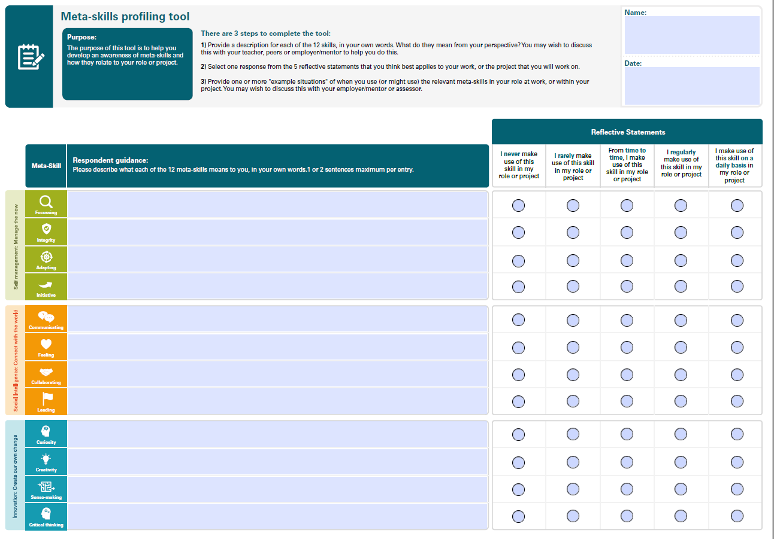
Meta-skills profiling tool page 1

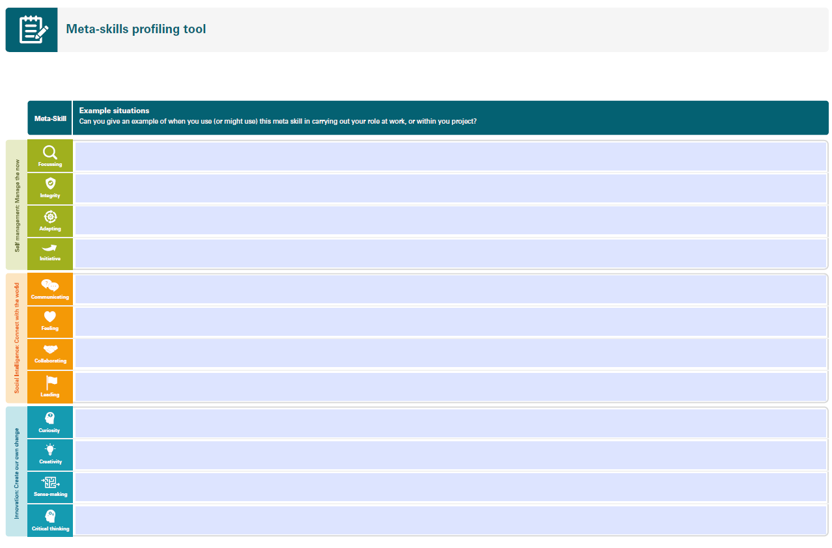

Meta-skills profiling tool page 2

Appendix 4: Using the SDS meta-skills self-assessment tool

The SDS meta-skills self-assessment tool (see screen grabs below) exemplifies one approach to guiding and capturing the apprentice’s reflections and evaluation of their personal meta-skills profile, using 2 criteria:

- The degree to which the apprentice is aware of each of the relevant meta-skills, what they look like in practice and how they can help the apprentice carry out their job role.
- The level of confidence of the apprentice to put each meta-skill into practice in their job role.

The 2nd page of the tool provides apprentices with space to select the strengths and areas for development they would like to focus on during their next development cycle.

The tool contains guidance for the apprentice and can be used/delivered in several ways:
- As a professional discussion with an assessor logging the apprentice’s responses and using the tool as a prompt for the conversation – this is recommended at least initially, or until the apprentice is comfortable with the exercise.
- As an individual exercise where the apprentice inputs responses into the editable pdf and arrives at an understanding of their current strengths and areas for development.
- As a means of periodically checking meta-skill development (by completing a new version) as the apprenticeship progresses; for example, if the apprentice completes the self-assessment on 3 occasions, it will help them to track the progress of their development. This will allow for adjustments to be made, if necessary, to the apprentice’s personal development actions for meta-skills as part of their individual learning plan.

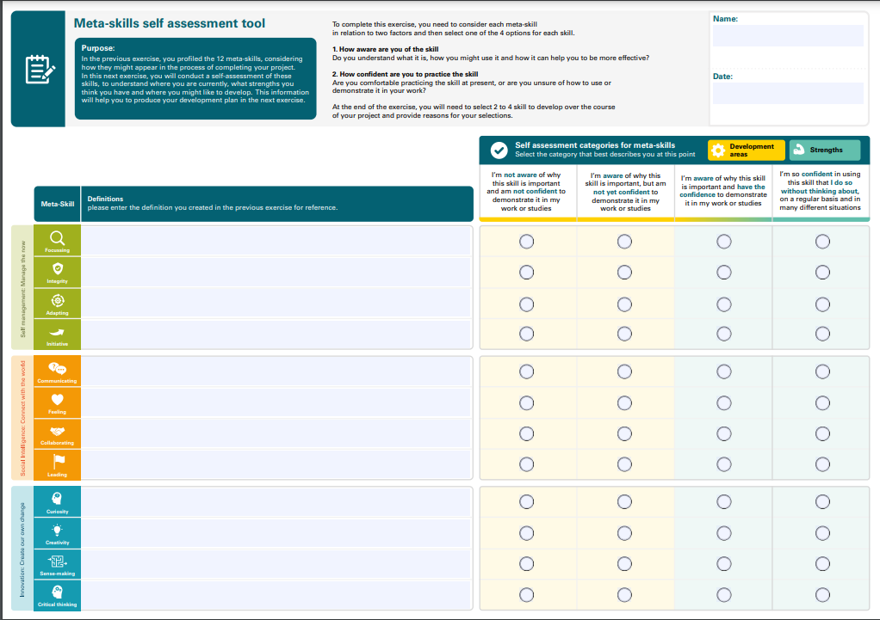

Meta-skills self-assessment tool page 1

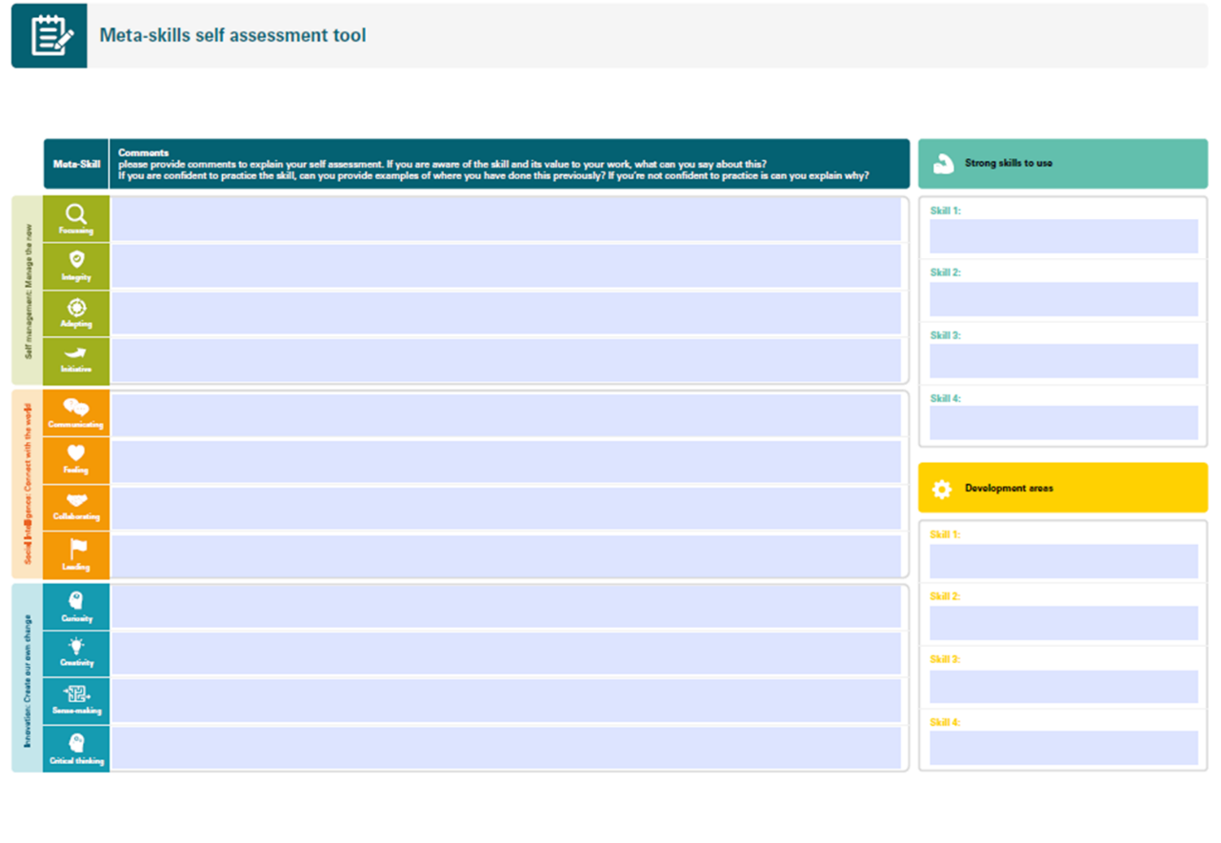

Meta-skills self-assessment tool page 2

Appendix 5: Meta-skills Professional Discussion Prompts

Reminder: 12 meta-skills are focusing, integrity, adapting, initiative, communicating, feeling, collaborating, leading, curiosity, creativity, sense-making and critical thinking.

- Describe a workplace situation or project you were involved in where you felt there was an opportunity for you to develop your meta-skills. Were you part of a team? What role did you carry out, who did you report to? Did you have responsibility for anything specific? Did you have any choice in what tasks you did? Were there any permissions or legal frameworks you had to work within? How was the progress of the work measured? What was the expected outcome? How did you measure the success of the work.
- What meta-skills did you identify an opportunity to develop or enhance in the work situation or while working on a project? Refer to your original self-evaluation profile and what each meta-skill means to you. Describe how individual parts of your work situation provides opportunities for developing specific meta-skills.

- Describe how you have progressed in the workplace and result of the workplace situation or project and reflect on how it has gone. Has it progressed according to plan, is the result as expected? Why did it not go according to plan? Which parts of the work went well, and which did not? What problems did you encounter? Could these problems have been anticipated? How did you resolve any problems? How do you feel about the outcome of any specific piece of work? What parts of the work would you change? Are there things that need changed that are out with your control – if so, how do you address this?

- Which meta-skills have you successfully acquired or developed as a result of tasks carried out in your workplace? Refer to your original expectations in section B and your original self-evaluation profile and reflect on how these have been developed during the workplace activities. Describe the specific meta-skills and how your work helped you develop them. Were there any further meta-skills that you developed above those expected at the? What particular tasks in the workplace helped you developed these? How confident are you at using these skills? Has your awareness of any meta-skills increased? How will you use these meta-skills you have developed in future work? How will your developed meta-skills affect others in the workplace?

Appendix 6: Meta-skills reflection guidance

Quality Assurance Guidance for meta-skill delivery

What does good look like in meta-skill delivery in Modern Apprenticeships?

 | A good provider will… | An excellent provider may also…
Facilitation of  meta-skill delivery | - Introduce meta-skills to apprentices using clear, workplace contextualised language aligned to those? in the standards for their apprenticeship framework  - Liaise with the apprentice’s employer and mentor to support awareness/shared understanding of meta- skills for their particular workplace and agree with them naturally occurring opportunities to discuss and reflect on the development of them (e.g. work inductions, 121s, performance review meetings)  - Seek natural opportunities, through liaising with the employer and apprentice to develop each apprentice’s meta-skills  - Facilitate meta-skill development of their apprentices using a proportionate coaching approach, developing their reflective practice skills, commensurate with the SCQF level of the apprenticeship framework (see SCQF levels below)  - Differentiate/adapt their coaching approach to support apprentices who face barriers to engaging effectively with reflective practice processes | - Use the employer’s voice to influence the design of meta-skill development opportunities, clearly linking to each apprentice’s job role  - Develop innovative and creative ways to introduce, develop and record meta-skills for their apprentices  - Support their partner employers to invest in developing their apprentices’ meta-skill development  - Support staff with sharing and standardising practice ¹to optimise apprentices’ development of meta-skills

¹ Standardisation focusing on the quality and equity of the PROCESS. Is it continuous? Is it authentic? Is the reflective practice consistent with the level of the apprenticeship?

- Support apprentices to record clear evidence of their meta-skill development journey linked to their reflective activities
- Will seek to create or signpost opportunities for holistic assessment of meta-skills in tandem with technical knowledge, skills and behaviours
Impact of meta- skill delivery | - Enable Apprentices to articulate their own development of meta-skills using shared common language aligned to the needs set out in the specific industry framework  - Involve and engage employers with the development of their apprentices’ meta-skills and enabling them to realise the benefits (better employees who are more skilled and motivated | - Engage apprentices to be confidently and successfully and articulate and effectively apply their meta-skills in their career journey  - Engage employers to actively invest and realise the benefits of developing meta-skills in their employees, for their business

Guidance on level of reflective practice expected for different SCQF levels

Level 4
Criteria | Expectation of reflection evidence
CONTEXT | Apprentices will be able to make a basic judgement statement on their meta-skill development through a facilitated/supported conversation and identify linked evidence for the judgement in relation to one or two routine and familiar work tasks.
EVIDENCE | Through supported dialogue, apprentices will describe some routine work situations and reflect on how well they demonstrated some of their meta-skills, using their own interpreted language for those skills. They should be able to demonstrate that they can reflect on previous self-assessments and, with prompting, identify the progress they have made.
LANGUAGE | Language in the self-assessment judgement statement may be straightforward (e.g. getting better; still need to work on; good, very good; need to improve) and identified links to the work task evidence are broad in relation to their own performance only.
FURTHER ASSESSOR GUIDANCE | The assessor is likely to use a coaching and supported dialogue (frequent prompts and probes) completing the self-assessment as the discussion takes place. Prompt questions might be- tell me about some work situations and relate them to some of the definitions we have for meta-skills Probe point, for example, for collaboration might be “Tell me about how you work with someone else to get your jobs done better and faster?”
Level 5
Criteria | Expectation of reflection and evidence
CONTEXT | Apprentices will be able to make judgement statements on their meta- skills development on their own. They are likely to engage in the self-assessment process autonomously initially and may adjust the content following a coaching discussion with the assessor
EVIDENCE | Supporting evidence from a few work tasks in mainly routine and some non-routine contexts should be given. They may reflect on their performance as an individual and within a team context.
LANGUAGE | The language in the self-assessment judgement statement may be straightforward with apprentices using their own interpreted language for those skills and provide some evaluative language (e.g. getting better; still need to work on; good, very good; need to improve) but should demonstrate some link back to the underpinning evidence (e.g. I wasn’t great at X and so we ended up having to do Y so I need to get better at that)
FURTHER ASSESSOR GUIDANCE | Apprentices are likely to engage in the self-assessment process autonomously initially and may adjust the content following a coaching discussion with the assessor/ employer.

Level 6
Criteria | Expectation of reflection and evidence
CONTEXT | Apprentices will be able to make judgement statements about their meta-skill development, demonstrating a sound theoretical understanding of the skills they have developed without support from their assessor.
EVIDENCE | Supporting evidence will link clearly to sometimes quite complex work situations that may involve e.g. team problem solving and research/investigation.
LANGUAGE | Reflective statements should relate clearly to a variety of work-related situations both routine and new/novel using evaluative language (e.g. effective, efficient, could be enhanced). Apprentices should, with or without limited coaching support, be able to provide work task evidence for their reflective statements and be clear about the impact it has on their own professional development as well as others around them.(e.g. as a consequence of X, this meant that we didn’t get Y done and so this meant Z for my colleagues and me) They should be able to demonstrate what they need to do to develop their meta-skills to work more effectively and efficiently in that workplace and relate the changes in their skills development to their own career journey.
FURTHER ASSESSOR GUIDANCE | Apprentices will engage in the self-assessment process autonomously and verified through a coaching discussion with the assessor.
Criteria | Expectation of reflection and evidence
CONTEXT | Apprentices will be able to make and articulate judgement statements about their meta-skill development demonstrating strong theoretical understanding of the meta- skill areas.
EVIDENCE | Their supporting evidence will relate to complex work situations, which may be of a professional or ethical nature.
LANGUAGE | The language should be evaluative and explicitly and cohesively linked to the work situations and describe the journey and impact of their skills development has on themselves, others within the workplace (immediate and wider) and the business itself
FURTHER ASSESSOR GUIDANCE | Apprentices should engage in the self-assessment process autonomously and verified through a challenging professional discussion with the assessor. They may utilise the STAR approach to be prompted in the conversation

Level 7
Level 8
Criteria | Expectation of reflection and evidence
CONTEXT | Apprentices will be able to make and articulate detailed judgement statements about their meta-skills development. They will demonstrate a strong theoretical understanding of the meta-skills areas.
EVIDENCE | Apprentices supporting evidence should relate to areas of professional/ethical activity including examples that relate to running established operations, systems or services, a few of which may be complex in nature. They should be able to describe their journey in developing the skills and the impact their skills development has on themselves and any teams they are responsible for and any managers they are responsible to.
LANGUAGE | The language should be complex, evaluative and demonstrates a critical evaluation of their meta-skills development.
FURTHER ASSESSOR GUIDANCE | Apprentices should engage in the self-assessment process autonomously and verified through a challenging professional discussion with the assessor.
Criteria | Expectation of reflection and evidence
CONTEXT | The candidate will be able to make and articulate detailed judgements about their meta-skills development. They will demonstrate a strong and detailed theoretical understanding of the meta-skills areas.
EVIDENCE | Apprentices supporting evidence should relate to a range of professional activity, including examples that are complex and include a degree of unpredictability. Examples may relate to dealing with professional codes of practice, organizing professional teams and showing awareness of future planning. They should be able to describe their journey in developing the skills in detail and the impact their skills development has on themselves, any teams they are responsible for, and any managers they are responsible to.
LANGUAGE | The language should be complex, evaluative and demonstrate a critical analysis and evaluation of their meta-skills development.
FURTHER ASSESSOR GUIDANCE | The candidate should engage in the self-assessment process autonomously and verified through a challenging professional discussion with the assessor.

Level 9

Appendix 7: Record of Meta-skills Development (completed)

Apprentice Name:_____Joan Smith______ Date:_____28/2/22____

Assessor:____John Brown________

Meta-skill developed:  Focussing ☒  Integrity ☐  Adapting ☐  Initiative ☐  Communicating ☒  Feeling ☐  Collaborating ☒  Leading ☒  Curiosity ☐  Creativity ☐  Sense-making ☒  Critical thinking ☐ | Summary of Work Situations:  My main role at work over the last few months has been to lead on a project to design and implement a new summer bedding area within the local park. I was responsible for the design aspect of the project and was in charge of a small team of 2 for the implementation of the design. Instructions were given from the area manager for the local authority who had also given me a budget for the work. The project timeline was planned on a simple spreadsheet. The first stage was to meet with representatives of the local neighbourhood who use the park and listen to their views on what design, plants and colours they would like. I had to discuss what parts of their requests were possible and explain why some were not and then come to an agreement in principle. I then had to draw a design for the new bed and source the plants, ensuring I could get the varieties I wanted at the appropriate time and within budget. A final design and planting scheme was then developed. During the next few months I worked with the team to prepare the new bed and kept in contact with the grower to ensure all plants would be delivered on the correct date for planting. A few weeks after the planting was complete the neighbourhood group visited together with the area and all were very pleased with the result and the area manager said the project was successful.  I identified a number of opportunities to developed meta-skills during this work. My self-assessment had identified communicating as one of the skills I was aware of but did not have the confidence to demonstrate it in my work and this project would involve me communicating with the area manager, the local community group and the team of labourers who were helping me implement the project. This should also help enhance my leading skills as it is the first opportunity I have had to lead and manage a project and team and I am still not confident in this skill. I also see an opportunity to use and enhance my focussing skills which I already feel confident in using and use on a regular basis.  While overall the result of the project was good and the new bed looks very good and has been admired by many the end result is quite a bit different from my original thoughts and plan. The number and range of variables that came up was much more than I expected e.g. my original plant order had to be changed 4 times due to changes in plant availability weeks after my order had been submitted. Weather also caused a delay in the project as the ground was too wet to prepare the bed at the planned time and we then struggle to get the bed ready in time for the plant delivery.  There are many things I would do differently if I was doing a similar project again. I didn’t appreciate how many changes there would be to plant availability after the order has been made. In any future designs I will make sure I have a back-up plan in place as to what changes will be made if the chosen plants are not available. Timing – my initial progress plan had very small windows for each activity to be carried out. In reality everything took longer than expected so more time needs to be allocated for each task. In future projects my timescales need to be more realistic. When working in public areas such as parks and gardens I will need to be more aware of the feelings of the general public who use the areas. This would be particularly important if I was carrying out a task that was more sensitive such as removing trees or bushes.  During the project I did increase my confidence in communicating and leading. I learned the importance of clear and timeous communication and how to get the best out of the team I was leading. I also enhanced some other meta-skills that I had not been confident in e.g. Adjusting. All through the project I was having to make changes based on new information, from plant availability changes to delivery time and weather I was constantly having to update and make changes to my plan. I now feel I am confident in using this skill in many other situations. Another skill I developed which I was not aware of in my self-assessment was feelings. During the project I was surprised by how much the local neighbourhood group cared about the project and how invested in the project they were. When changes had to be made e.g. in plant choice I always made sure I explained why the change had to be made. This is the first time I have had to take account of the feelings of others in carrying out my work.

Appendix 8: Meta-skills Development Summary (completed)

Apprentice Name: Joan Smith |  | Modern Apprenticeship details: MA in Horticulture at SCQF Level 6
GENERAL INFORMATION:

The apprentice above has developed a range of Meta-Skills and has shown reflective practice at SCQF Level 6 and is able to engage autonomously in self-assessment making judgement statements on their meta-skills development in some complex work situations.

As part of her Modern Apprenticeship in Horticulture Joan had a number of placements and was involved in a number of projects and work activities which used, enhanced and developed her meta-skills. Some of these projects included:

Meta-Skills developed | Evidence Summary
Leading - create a sense of direction, influencing and encouraging others to achieve goals, review the work of others.  Collaborating - identify and initiate connections, working towards shared goals, aware of others’ reactions.  Creativity - explore ideas not in the present environment, translating information, arrive at new solutions.  Communicating - processing verbal or written communication, listening, giving information and storytelling.  Focussing - focus without distractions, sorting into categories and filtering out non-essential information  Feeling - understand the feelings and emotions of others and social conscience.  Integrity - understand and manage emotions, having personal values and principles, exercise control of emotions.  Critical thinking - breaking down a complex problem, identify and evaluating situations, understand data-based reasoning.  Communicating - processing verbal or written communication, listening, giving information and storytelling.  Adapting- open to ideas, critically reflect on experiences, self-educate and respond to evolving challenges. | Joan has been working with the team who are responsible for the planning and implementation of a project to redesign and plant a new range of summer bedding displays within the local park. This has involved reviewing the existing provision and adjusting the planting plan to take account of the reduced budget and new varieties of plants available. The design was to celebrate the 25th anniversary of the local authority and Joan led on the design, initially meeting with the local community group to get their ideas then drawing the design and selecting the plants. She then briefed her colleagues and led in the implementation of the design within the park.  Working with the team responsible for grounds maintenance in the cemetery Joan’s job also involved preparing ground areas for burials. She had to pay close attention to orders that came in, ensuring the correct plot was opened up at the correct time in preparation for a funeral. She had to be present during the burial, always being aware in case she was required to help lower the coffin. She also had to be sensitive to the grieving families’ requests such as them wanting to put personal items in the open grave which wasn’t permitted. In her dealings with families and members of the public she had to be very careful in relation to the confidentiality of the information regarding a burial.  During her time working with the nursery staff Joan was responsible for the ordering and production of plants that were required by the local authority for up to a year ahead. She had to collate orders forms from a range of areas and scheduling the purchase or production of the plants. This often involved changing the requested plants to those that were more cost effective, provided a better display or were more suitable for the area requested and communicating these decisions to the respective managers.

Appendix 9: Blank Templates

Record of Meta-skills Development

Apprentice: ______________________________ Date: ______________

Assessor: _______________________________

Meta-skill developed:  Focussing ☐  Integrity ☐  Adapting ☒  Initiative ☐  Communicating ☐  Feeling ☐  Collaborating ☐  Leading ☐  Curiosity ☐  Creativity ☐  Sense-making ☐  Critical thinking ☐ | Summary of Work Situations:

Meta-skills Development Summary
Apprentice Name: |  | Modern Apprenticeship details:
GENERAL INFORMATION:

The apprentice above has developed a range of Meta-Skills and has shown reflective practice at Choose an item.

Meta-Skills developed | Evidence Summary
Choose an item.

Choose an item.

Choose an item.

Choose an item.
Choose an item.

Choose an item.

Choose an item.

Choose an item.

Choose an item.

Choose an item.

Choose an item.

Choose an item.

From now on referred to as “assessor”

